Why You Need Someone in Charge of Employee Engagement Immediately

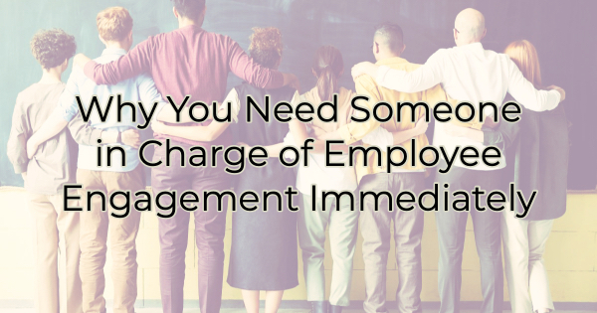

At the risk of sounding like a broken record, engagement is critical to your business. Now more than ever. It’s so important that I wish I could create a new name for it so people would pay more attention. Being told you need to engage your audience is not new, but the pandemic has created a bunch of new reasons why it’s incredibly important, especially with employees. If you don’t have the time, you need to make it or hire someone who does.

Engagement Is Important Because…

Your Employees Are Hanging on by a Thread
A few things are going on in the employment sector these days. In most areas, there are more open positions than people looking. That means successful employers of choice are paying solid wages and not making their employees feel like a number.

You might be surprised that many employees working remotely (68%) are admitting they are interested in freelance work on the side. This can be a gateway to them starting their own business or going out on their own in some capacity. Unless they are completely enamored by your company (engagement can accomplish this), it’s only a matter of time before they build up savings, clientele, or secure healthcare to take the leap.

For employees who are not remote, the number of available jobs in most industries could be causing disengaged employees to consider other options. A certain amount of attrition is not always a bad thing but when it starts affecting your top performers, your business will feel it.

If you engage them now and help them feel like they are bringing something meaningful to your business, they will be less likely to leave. And…

They’ll Talk About You
Whether it’s your employees or your customers, you want them to talk about you (in a good way) and refer others to you. Engaged groups do that. People who see you as simply meeting their expectations (or writing a check to them every two weeks) won’t.

They Could Become Your Next Competitor
Another thing COVID did was invite people to reevaluate their jobs and lifestyles. This has caused some to think about starting their own business. In fact, 63% of employees think they could quit and start their own. So, it could be only a matter of time before the proper alignment of the stars occurs and they become your newest competition.

Take Action Today
It doesn’t do you any good to hear how important engagement is without getting some tips on how you can start engaging. Ideally, you will commit to employee engagement at your business and doing so will affect every decision made. However, there’s no time like the present. While you’re working on the larger commitment to employee engagement, here are a few easy ways to start engaging them immediately:

- Ask your employees’ opinions or views on things concerning your business. Getting feedback from them can be invaluable.
- Give constructive criticism on the job they are doing. Don’t wait for an annual review.
- Review salaries to ensure they are keeping up with the recent rise in cost of living. A surprise increase can make people feel really good and valued.
- Tell them you value them for their specific achievements. Giving details on what they do well will drive them to do more of it.
- Compliment them in front of others. Correct them alone/individually.
- Find out where they want to be in the future and help them chart a path for that.
- Encourage growth and learning. Reward them for pursuing those things.
- Encourage sharing ideas for innovation, market expansion, and cost-savings. Reward employees for the ideas that you use.
- Look for ways to surprise and delight them just like you would your customers.
- Find out what work obstacles they face and remove them.
- Encourage employees to share stories and comment on social media.
- Help them understand your mission and why your company does what it does. Why is the mission important and what does it mean to people who do business with you?
- Ask your customer-facing employees to share stories of success with the rest of the business.

Employee engagement is about helping employees feel they are a valued part of something larger, seeing themselves aligned with your operation, and feeling like they contribute to the success or failure of a project or the company as a whole. You want to cultivate a culture of caring, one in that employees care about customer outcomes and they feel like you care about them.

Christina R. Metcalf (formerly Green) is a marketer who enjoys using the power of story and refuses to believe meaningful copy can be written by bots. She helps chamber and small business professionals find the right words when they don’t have the time or interest to do so.
Christina hates exclamation points and loves road trips. Say hi on Twitter or reach out on Facebook.

