What’s in Chamber Membership for You? Hint: it’s more than just a ribbon cutting

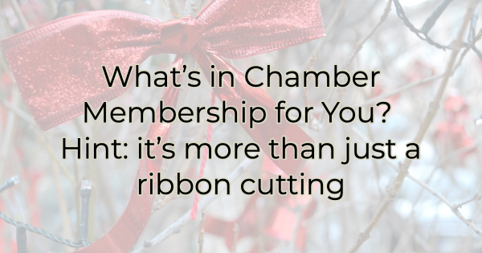

Years ago, businesspeople joined the chamber because it was expected. It was just something you did. These days membership isn’t automatic but it’s still a valuable investment in your business. In addition to networking events and ribbon cuttings, the chamber offers a lot of benefits that you can’t do for yourself, and chamber benefits can save you a lot of money. If you’re like most business owners, you could really use some cost savings these days.

Before we go into exactly what the chamber can do for you and your business, it’s important to note that chamber membership is not like a gym membership that comes with one entry and the occasional ability to bring a guest. Chamber member benefits apply to all your employees and each of them has full access. Smart businesses share this information with their employees and even add events and learning opportunities to the company newsletters and/or intranet/employee portal. Many market these benefits as an extension of their own, which can help you give your employees opportunities that may not be in your budget. Here are some of those highlights:

Chamber Membership Perks for You and Your Employees

- Learning opportunities. The chamber offers many learning opportunities throughout the year. Some are conducted by staff, while others are led by community experts. Topics vary but are always centered around information that benefits businesses. Past topics include <insert topics>. Check out our calendar for this month’s offerings.
- Increased backing. One voice in a sea of many gets drowned out easily. But when multiple voices are insisting upon the same thing, leaders are more apt to listen. When you join the chamber, you add your voice to the strength of the chamber and together we can cohesively help protect your interests. When we assist members with zoning or advocacy issues, we often hear, “We couldn’t have done it without you.” The chamber has a powerful voice, and we can speak for you in a persuasive way.
- Powerful credibility and a sense of community. Many people see chamber membership as an indication of trustworthiness. It shows you care about the community and are here to make a difference. These days that’s appealing to people. They want to do business with organizations that share their views and values.
- A group with shared interests. Everyone knows that the chamber provides excellent opportunities for networking and increasing your business. But the other thing that makes these networking events (and all chamber events) more appealing is that everyone there has a business focus as it applies to our community. You will quickly discover many commonalities that make connecting easier. In addition to possible sales opportunities, you may discover partnership possibilities and other ways to mutually fulfill your goals.
- Affordable advertising opportunities. If your ideal market is business professionals, the chamber offers a host of affordable advertising opportunities. From newsletters to banner ads, event sponsorships to speaking opportunities, the chamber can tailor an advertising package that not only places you in front of your target market but also does so in a way that helps you cut through the marketing noise of other platforms.

Chamber membership may no longer be the automatic activity that it once was but it is an excellent way to position yourself in the community, establish respect, and get the assistance you need to grow and thrive.

Christina Metcalf is a writer/ghostwriter who believes in the power of story. She works with small businesses, chambers of commerce, and business professionals who want to make an impression and grow a loyal customer/member base. She loves road trips, hates exclamation points, and believes the world would be a better place if we all had our own theme song that played when we entered the room. What would yours be?
_______________________________________
Twitter: @christinagsmith
Facebook: @tellyourstorygetemtalking
LinkedIn: @christinagsmith

