Small Business Season’s Secret Weapon: Email

Okay, so this might not be a “secret” weapon, but email marketing can help extend the push to shop small that began on Small Business Saturday. These types of gentle reminders can keep customers buying from you all season (and all year) long. You just need a couple of great ideas, an email marketing tool (like MailChimp or Constant Contact), and of course an email list.

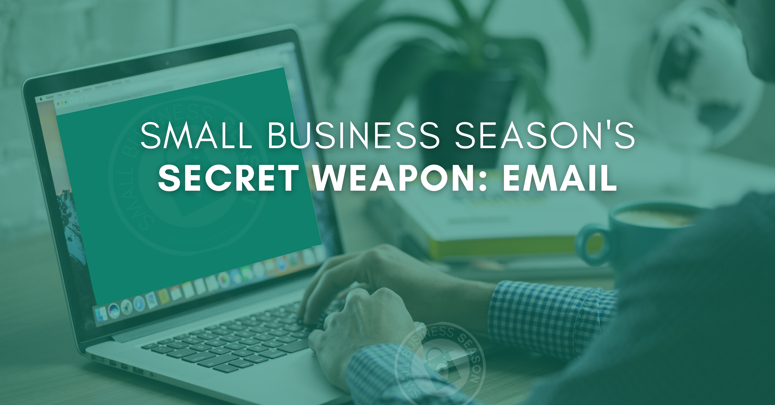

Email List Building
If you don’t have an email list, begin building one right away. Add a sign-up sheet or QR code at your cash register. Tell people if they sign up for your list that they’ll be the first to know about new products or services as well as discounts. Call the list something intriguing like an Insiders Group or VIPs.

Everyone who orders/buys or visits your site/store should be given the opportunity to become part of this exclusive list.

Always ensure you have their permission to send to them. It’s annoying (and potentially illegal depending on where they are located) to send without their permission.

Email Marketing

Assuming you have at least a small email list to begin with, you’re ready to use this “secret” weapon to build upon the momentum you started on Small Business Saturday and transfer it to a Small Business Season of wonderful sales.

Offers
As a small business, it’s extremely important to be known, liked, and trusted. Emails can really help with that. Instead of sending out mass sales emails like the big stores do, use this opportunity to connect (and sell) to your list.

You do this by:

- Sharing things about yourself that people can identify with.
- Educating people on new uses or needs for your products or services.
- Using multiple forms of media inside your email (you can add video or provide a link).
- Creating a beautiful and branded design. Branding helps them identify your emails without reading or wondering who they’re from.

Every email should contain an offer. An offer could be a great sales deal, but it could (and should) also be something they want. One out of every three emails should be a sales deal or discount, but the other emails should offer them something they need like a tip, suggestion, etc. We call them offers because there should be an active component to it, but it needn’t be sales related, It could be something useful that is an extension of what you sell such as “Click here to find out how to set the perfect table,” if you sell furniture. This offers them information for performing an action. The URL click shows their interest. It’s active, not passive. That’s key to email marketing. Providing an “offer” allows you to see who is interacting with your emails.

Call to Action
A call to action is important on every email, but incredibly important on those where you’re making a sales offer. Don’t forget to ask something of them. By doing so, you are inviting them to continue your relationship. They’re already interacting with you, make it mean something.

Frequency
You don’t want to annoy your audience with emails multiple times a day, but you also want them to think of you. You want to be top of mind.

Consider using this idea to send emails every couple of days. Be creative. Make an impression. For instance, you can use national days of celebration that have nothing to do with what you sell in the email subject line like “It’s National Puppy Day so…”

Then when they open the email, your content might read: “Yay! It’s National Puppy Day and that has nothing to do with tacos. But both are really awesome. You are too. And since being awesome is hard work, you deserve a taco. Check out our BOGO offer for Taco Tuesday (AND National Puppy Day!).” It makes no sense but it’s memorable and it’s a limited-time offer. In the sea of holiday emails, you need that.

Frequency builds brand recognition and makes recipients think of you. But that can also lead to boredom and auto deletes. When emails are creative, recipients won’t get bored of seeing them and when they are funny or original, recipients will click to see what you’re writing about.

Small Business Season helps you build on the momentum of the shop small surge from COVID. If you want it to bring your small business more customers, you need to actively market to stay top of mind. Email marketing is one of the least expensive and easiest ways to do that.

Christina R. Metcalf (formerly Green) is a marketer who enjoys using the power of story and refuses to believe meaningful copy can be written by bots. She helps chamber and small business professionals find the right words when they don’t have the time or interest to do so.
Christina hates exclamation points and loves road trips. Say hi on Twitter or reach out on Facebook.

