Easy Last-minute Bonuses to Drive More Sales During Small Business Season

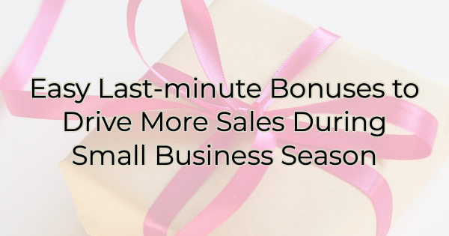

Bonus offers are a great way to drive sales without discounting your products or services. It makes people feel like they are getting extra value—and these days, with inflation—that can make a reticent customer buy quicker.

But what if you haven’t thought out an entire marketing strategy around bonuses? Is it too late to offer one? Not at all. Below we have some ideas on how you can make the last few weeks of Small Business Season some of your best.

Offer a Bonus Gift Card
Give a small gift card ($10-20) with every purchase of $100 or more. The buyer will appreciate the bonus because of its versatility. The smaller card can be used as a tip for a service provider, a gift for themselves, a stocking stuffer, or a teacher gift. It’s like getting two gifts for the price of one.

Add a Coaching or Instructional Session
This is a low-cost bonus that can help an unsure customer act quickly when an expiration date is set. Offer your time as a bonus to a higher spend. If you don’t have the time to offer your undivided attention, give them a free pass to a class you’re offering in January. For instance, if you sell craft supplies, you can encourage novices to take up a hobby by bundling a starter kit of knitting materials and throwing in a free class to learn how to use them. Which brings up…

Bundling Goods That Go Together
You can create a nice gift basket or starter kit and package it beautifully for a very thoughtful gift. If you’re a service provider, think about a few items you could add with a gift card for your services. You might even be able to work together with another business to include their goods with your services.

Provide a Bonus Download
Create an electronic freebie for download with purchase. You could also use this freebie to build your e-mail/mailing list, no purchase required. Both are good ways to give your audience something of value in exchange for their contact information. This allows you to stay in touch throughout the year.

Give a Bonus Review
If you are a service provider, you could offer a free/bonus audit or review with the purchase of a service package. For instance, if you’re a web designer, offer a free SEO audit.

Provide Free Shipping or Delivery
Offering free shipping is a great way to entice people to buy. Set a minimum spend for free shipping or you could run up expenses with very little revenue to show for it. Setting a minimum also incentivizes people to spend a little more to qualify for it. Another option to drive purchases is offering free delivery. If you do this, define your delivery area or gas costs could eat into your profits.

Throw in Some Goodies
December is the ideal time to give away samples, especially to people who are already buying from you. If you sell food, add a giveaway to every purchase. If you don’t sell food, include a small treat with a cute message about how important the customer is and how much you appreciate them supporting small business.

Be a Personal Shopper
If you have the manpower, you could offer free personal shopping via Facetime where you walk someone around your business virtually and help them pick out their ideal gifts. You can also offer this service without the Facetime component and do the shopping for them yourself. In that case, make sure you perform your due diligence to find out the likes and dislikes of the person you’re shopping for.

Christina Metcalf is a writer/ghostwriter who believes in the power of story. She works with small businesses, chambers of commerce, and business professionals who want to make an impression and grow a loyal customer/member base. She loves road trips, hates exclamation points, and believes the world would be a better place if we all had our own theme song that played when we entered the room. What would yours be?
_______________________________________
Twitter: @christinagsmith
Facebook: @tellyourstorygetemtalking
LinkedIn: @christinagsmith

