Do You Have These 10 Things on Your Business Website? You Should.

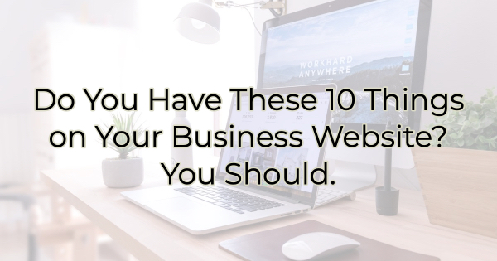

If you’re a small business, you probably bootstrapped your website content, picking it up here and there, copying what you like from other sites (hopefully not word for word), and adding as you go. That’s the way most small businesspeople do it unless you’re lucky enough to know someone who offered their writing services or have it in your budget to have it written for you.

But do you ever wonder if you have the type of content that will transform the casual web visitor into someone who buys?

Here are the components you need on your website to ensure more sales conversions.

Top 10 Most Critical Website Content
Don’t let this list overwhelm you. While it’s extensive, you can check these things off as you go or work with a copywriter and designer who can accomplish most of this quickly.

If you want more sales, you need these things:

- Keyword rich content. You need people to find you, but you also want them to read your content. It takes finesse to write for humans and search engines. Make sure you have plenty of keywords in your text for SEO but that they work in a way that will also be appealing for your audience.
- Mention of where you are. Your website can be seen all over the world and you’re not the only “Columbus” out there. Somewhere you need to mention your area. This not only tells visitors if they can come take a look in person but also helps with SEO and local web referrals. Many businesses incorporate the mention of the surrounding areas in their content, not just in the footer.
- Call to action. People are spending time with you. Give them a next step with a call to action. Make sure your CTA matches the page the visitor is on. “Learn more” linking to additional resources is a solid choice for introductory pages. “Work with us” is better for more in-depth content.
- Links to social media. Most people won’t continue to return to your website to interact with you, but they will check to see what you’re doing on social media since they are already there. Make sure you only include the sites you are active on. There are no prizes for listing the most social media profiles.
- Things you’re doing. If you host events or are participating in a festival, make sure people know. Tell them where they can find you outside of your business.
- Your personality. You don’t want to look (and sound) like everyone else. Let your personality shine through in your content. Even if someone else is writing it for you, make them aware of what tone you want and give them examples.
- What your audience wants. This may sound like broad advice, but good content reflects what your customers and potential customers want from you, whether that’s information/education, entertainment, or inspiration. A hardware store, for instance, may find DIY project content gets a lot of engagement or visits than straight text, while a florist may find that an album of floral designs is its most visited area of the website. Experiment with different types of content and media to see what gets the most action.
- Internal and external links. You want people to spend time on page, that means you want them to “hang out” on your website and get to know you. You do this by keeping them interested and giving them things to do. That’s where internal links come in. Use them throughout your content to help visitors explore in-depth. For SEO, you also want external links to high-ranking websites (always have these links open in a new window/tab so visitors can get back to your content easily). High-ranking websites like industry or news sites can be beneficial, linking to your next-door neighbor, less so.
- Security. Visitors want to feel safe. Talk to a cybersecurity person to find out not only how to achieve it, but what assurances you can give your audience that they are safe with you.
- Affiliations, awards, and testimonials. If you are affiliated with any community groups (like the chamber) or have won awards, add them to your site. If people are saying amazing things about you or you have excellent reviews, post them. These things will all serve as a testament to your value and improve your trust rating among new visitors.

These things are just the beginning of what you need in a high conversion website. There’s a lot more you can do but start off with these basics and you’ll be setting yourself up for success.

Christina R. Metcalf (formerly Green) is a marketer who enjoys using the power of story and refuses to believe meaningful copy can be written by bots. She helps chamber and small business professionals find the right words when they don’t have the time or interest to do so.
Christina hates exclamation points and loves road trips. Say hi on Twitter or reach out on Facebook

