Acing the Basics of Grant Writing

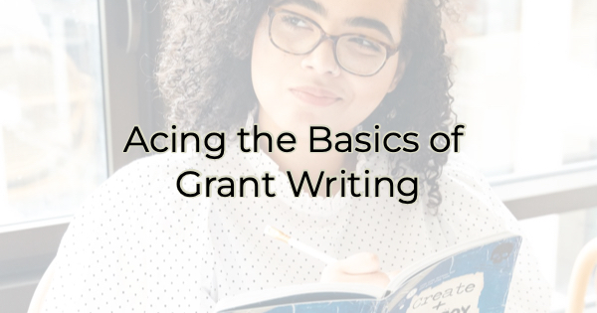

Hiring a grant writer isn’t cheap. Some charge a flat fee, while others base their fee as a percentage of the grant amount. If you’re a small business or nonprofit, you may not be able to afford to hire someone. But it is worth it. To take on grant writing yourself, you’ll miss out on the years of experience you’ll get with a professional and it will likely take more time. But if you’re looking for a DIY solution, you need to know the basics of grant writing.

Basics of Grant Writing
First, know that good grant writing is simply good writing. If you struggle with the basics of grammar, you either want to hire it out or hire an editor once you write it. However, one thing to keep in mind about grant writing is that even if you hired a grant writer, you would still need to give them the bullets to put together a compelling grant application. Knowing this, the rest of the writing is simply polishing. The points will always be yours anyway.

Another important aspect is research. Grant bestowers won’t contact you. You must apply. Half of the work in a grant is finding one that’s a good fit for you. Do you fit their criteria? If you’re lucky, you’ll be an obvious fit and hit all of their requirements, but for some you may need to (creatively) illustrate the fit for the person/group giving the money away to show them how you meet their specifications.

Assuming you’ve found a grant you’re interested in, do the following:

- Set aside time. A grant is not the same as a credit card application. It will likely take you hours to compile the information needed. If you want to be successful in your grant writing, clear the table, and make sure you have the bandwidth. Delegate, if you must. Applying for money is a big deal. Treat it that way. This is not something you want to write at home in front of the TV at night.
- Double check your eligibility. Don’t waste everyone else’s time applying for things you are not remotely eligible for. For instance, if the grant is for a Florida business, don’t apply as an orange grower from California hoping you can sneak in.
- Consider the fit between your group and the one giving out the money. Ever watch a sponsor drop a celebrity because they do or say something that is not in keeping with the sponsor’s brand? Well, you want to consider the same thing when applying for grants. Don’t take money from an organization that does not jive with your mission or beliefs. If you can’t tell from the grant offering write-up, do your own research on the group.
- Follow the instructions. Even if the grant is being awarded for creative pursuits, follow their directions. If they require a 500-word essay, don’t write a sentence, and submit that thinking it will be Avant Garde and make a statement. If they say 500 words, that’s what they want.
- Tell a story. If you watch America’s Got Talent or other talent show with judges or an audience selection process, you’ll notice that contestants who share their tearful stories of family members with cancer or lives spent living in vans, often when paired with a little talent, progress to the next level. A good voice can sound extraordinary when accompanied by a compelling story. Think about your focus, your passion, your successes, and your obstacles. Make people feel what you’ve gone through as you answer the grant questions. Your story will also help you stand out from other applicants.
- Use the right language. In addition to telling your story, you want to use persuasive, concise language. Don’t drone on and on thinking the more often you reiterate something, the more you’ll hit the point home. Imagine each word costs (you) money and use as few as possible (following their guidelines, of course) to prove your point and convince the decision maker that yours is the best entity for the money. Axe words like “really,” “actually,” and “very.” They add nothing to your application. Were things really hard or challenging? See the difference? The latter conveys feeling, the former doesn’t.
- Proofread. Then do it again. And again. We all make mistakes but not on applications for large amounts of money. Run your finished application by several people. Ask them to read for grammar/typos, as well as understanding. If they can’t follow your reasoning as to why you should be awarded the money, the grantor certainly won’t be able to either.

Christina Metcalf is a writer/ghostwriter who believes in the power of story. She works with small businesses, chambers of commerce, and business professionals who want to make an impression and grow a loyal customer/member base. She loves road trips, hates exclamation points, and believes the world would be a better place if we all had our own theme song that played when we entered the room. What would yours be?
_______________________________________
Twitter: @christinagsmith
Facebook: @tellyourstorygetemtalking
LinkedIn: @christinagsmith

