6 Ways to Use Promote Value in Your Product/Service

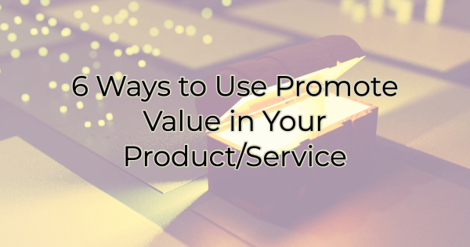

This morning, the headline inflation is at a 40-year high hit me before my coffee did. If you’re like me, and millions of other businesses, you’re probably caught between the idea of raising your prices to cover the increase in your own costs and providing your loyal customers with good value.

It’s difficult these days. I see many business owners apologizing for raising prices, but it can’t be helped. You need to make a profit to remain in business, yet your customers are likely struggling too. That’s why now, more than ever, you need to communicate the value behind your products and services.

Here’s how:

Communicating Value to Your Customers: 6 Solid Ways

Talk About What They’re Getting
When Little Caesars Pizza® recently raised their prices, they didn’t focus on the 11% price increase, nor did they justify the increase by marketing the message of how many years their price had remained the same (since they began in 1997). Instead, they focused on the message that their customers were now receiving 33% more pepperoni on their pizzas.

And who doesn’t want more pepperoni?

Focus on the Fear of Missing Out
Using the words “for a limited time” conveys value, even when it doesn’t mean cost savings. When you use that phrase, customers immediately think of a price reduction or offer that will only be around until it vanishes without warning.

You can use this language when you know a price increase is inevitable. Market your current offerings with the language “for a limited time” and then increase your price or run a special under that same language and then increase your pricing. You’re giving your customers one last opportunity to buy from you at a lower price.

Mention How They Can Save
This advice is specific to your business, services, and products but is there something additional that buying from you saves customers from purchasing? For instance, does your diet meal prep service save them money at the grocery store or keep them from spending money dining out? If so, try to estimate what that looks like. Put some numbers around it. Ask current customers what they save. What can your customers eliminate in their expenses by buying from you? Market those ideas.

Host Secret Sales
While it may be cost prohibitive to offer sales and discounts to everyone, why not offer flash sales to your newsletter subscribers or social media followers? You’ll drive more business in the short time you hold the sales, and you’ll make your loyal customers feel appreciated by offering them more for less.

Speaking of…

Let Them Know When to Buy
If you have loyal repeat customers, train your employees to offer savings tips to them. Give them a reason to return. For instance, if you run a products business where you get new selection of rotating stock in on Tuesday, for example, share that. People who love a good bargain will return again and again if they think they can get to the items first.

Use Pairings
If you need to increase prices, look for bundles you can create in your business to provide more value. What items or services can you combine to provide your customers with more? Most people don’t mind paying more if they feel like they’re getting more.

The good news is that most of your competition is doing the opposite. They’re raising prices and offering less such as smaller boxes, reduced quantity, etc.

If you’re like most business owners these days, you’re faced with the fact that increasing prices is inevitable. Even if it pains you to do so, your costs are increasing, and you likely must pass those along to your customers if you want to remain in business. If that’s the case, these ways to increase perceived value should help you both feel better about the necessity of doing so.

Christina R. Metcalf (formerly Green) is a marketer who enjoys using the power of story and refuses to believe meaningful copy can be written by bots. She helps chamber and small business professionals find the right words when they don’t have the time or interest to do so.
Christina hates exclamation points and loves road trips. Say hi on Twitter or reach out on Facebook.

