6 Email Subject Lines That Get Clicks

Your email content can be the best ever but if people don’t open your emails, the emails might as well be blank.

Two things make recipients click: who it’s from and how appealing the subject line is. In that order. That’s one reason I advise businesses to send their emails from a person (or at least an email that resembles one), not “no-reply@biz.

But how do you make your subject lines more irresistible? How do you inspire clicks and drive them to open your emails? Try these types of emails.

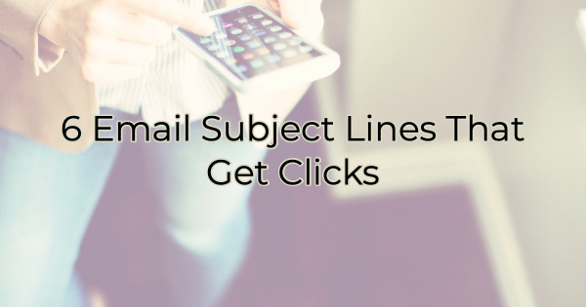

6 Types of the Most Clickable Emails
Think of your own inbox and how many emails you receive during the day. Most of us are on fast delete or swipe when we’re clearing out emails. You need to grab the recipient’s attention quickly. Here’s how:

Solve a Problem
What does your product or service help people do? Or what is this email designed to do for them? What value do they get from opening and reading it? Be specific and brief.

Example: Get more sleep with Comfy Blanket or
Say good-bye to restless nights with this easy solution

Or solve a problem they haven’t considered yet.

Example: Get mom’s gift yet? Mother’s Day is next Sunday.

Add the Color
While simple vocabulary is important in a subject line, that doesn’t mean you give up painting a tantalizing picture. Use evocative imagery and appeal to their senses. Don’t hesitate throwing in an emoji or two (unless your subject or business is incredibly serious).

Example: Warm cinnamon apple pie is calling 🥧

Invite Curiosity
We’re naturally curious and when you factor in the fear of missing out, it can be a powerful motivator of clicks. If you’ve had a recent event or launch, you can use that to your advantage.

Example: Be the first to see our new spring line
See what our opening day participants did

Explain the Send
If your audience is similar to most people, they often sign up for things and forget them. In their defense, a lot of businesses sell contact info and then the new businesses claim you signed up for the list. While that may be true, the list you signed up for initially was not their list.

To differentiate yourself from these businesses, be specific when the information was (actually) requested by the recipient.

Example: Your requested newsletter from <business> or
The <download> you requested from <business>

Detail Benefits
People want to know why they should click. Tell them. If there’s a deadline, communicate that too.

Example: Today’s top deals under $100 or
Unlock access to free delivery or
How to get a FREE <product or service>

Give Them Something They Dream About
Everyone wants something but they may not feel like they can or should. They may view your product or service as a splurge or something they need to put off. Give them a reason to feel otherwise.

Example: Treat yourself to a luscious cake or
Reward your hard work with a new look
Cover the COVID grays with our newest treatment

Finally, keep subject lines under 41 characters (not words) as often as possible and consider how they will look on a phone. Figure out what words will be cut off. Sometimes the cut can make your message more evocative and interesting. Other times, it can look sordid or mean something you didn’t intend. Keep the message short and get right to the benefit. After all, that’s what people are most interested in.

Christina R. Metcalf (formerly Green) is a marketer who enjoys using the power of story and refuses to believe meaningful copy can be written by bots. She helps chamber and small business professionals find the right words when they don’t have the time or interest to do so.
Christina hates exclamation points and loves road trips. Say hi on Twitter or reach out on Facebook.

