20 Ways to Celebrate National Holidays

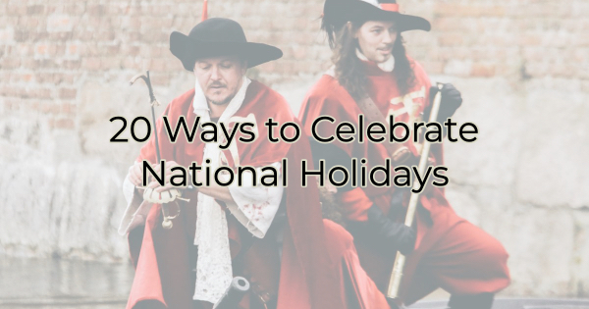

As I write this article, it’s not only National Empanada Day, it’s also National Zoo Lovers Day. And I plan to go to bed early to rest up for tomorrow’s big double celebration of National Winston Churchill Day and National Unicorn Day.

All in, there are 257 national holidays in April alone. If you’re like me, you may find them hard to keep up with, but they can be a great source of engagement for your business. You just have to know how to use them for maximum return and get a little creative.

Here are a few ideas:

Ways to Celebrate National Holidays
Celebrating these days serves to connect your audience with your business so make sure you have a little fun with this. You can:

- Host a sale based on the holiday.
- Provide a discount if your audience plays along like offering something at a discounted price if your customer orders it in a pirate’s voice on National Talk Like a Pirate Day (September 19th, if any of you are tracking that sort of thing).
- Write a blog post about it.
- Share it on social media.
- Create an image post for it.
- Create an infographic surrounding it.
- Post trivia behind it or associated with the topic.
- Ask people to share their pics of it (a really good idea on National Dog Day or other similar idea).
- Host an event surrounding it.
- Host a class that celebrates the day (like a knitting class on National Yarn Day).
- Tell a story that ties into the day.
- Create a video or lip sync to a song that epitomizes the day.
- Take the idea and change it slightly. Instead of National Talk Like a Pirate Day, create a video of your cat meowing and add a pirate hat. Suddenly it’s Meow Like a Pirate Day.
- Serve up goodies for free in your store on days like National Chocolate Chip Cookie Day. Give them away or give one away with purchase.
- If you already serve food in your store, create a special around the day available for a limited time only. Be as creative as possible.
- Interview someone who knows a lot about the subject of the day.
- Create an email campaign around the special day or week of celebration.
- Use the holiday to raise awareness of a cause that’s important to you.
- Highlight other businesses celebrating the holiday (like making a list of places offering free tacos on National Taco Day).
- Host a fun activity for your employees celebrating the day. Don’t forget to give it a hashtag just in case they want to post the celebration on their social media accounts.

National holidays can be a lot of fun, but they can also give you a great opportunity to connect with your business audience. You just need a little creativity, a good content calendar, and these ideas.

Christina R. Metcalf (formerly Green) is a marketer who enjoys using the power of story and refuses to believe meaningful copy can be written by bots. She helps chamber and small business professionals find the right words when they don’t have the time or interest to do so.
Christina hates exclamation points and loves road trips. Say hi on Twitter or reach out on Facebook.

