What’s Your Biggest Marketing Challenge?

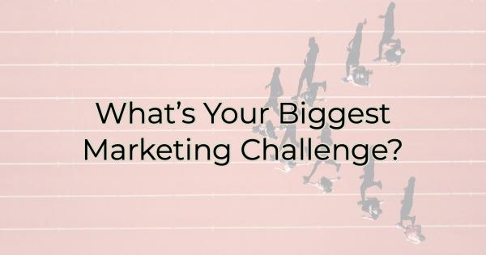

When a business operator finally decides they need someone focused on their marketing, and they resolve to hire for the position, it usually goes something like this:

“This position will be in charge of posting to our social media channels.”

But if that’s all you’re doing, you can put that in the hands of the nearest thirteen-year-old.

If you’re contemplating stepping up your business marketing, you need more than a scheduler. You need someone who understands the different kinds of marketing, your audience, and how to nurture prospects.
Marketing gold
Successful marketing looks like this:

What you want to say about your business

What your audience wants to hear/know

As you can see from the diagram, there’s a large area of information you want to share with your audience and there’s a large amount that they want to know or are curious about. But the area that overlaps between the two is considerably smaller. That means you must be deliberate and strategic in what content you choose to share. Too many topics or posts that aren’t of interest to your target audience, not only means a lack of engagement on their part, but also a drop in organic rankings and visibility on social media.

While the center of the Venn diagram is marketing gold, that does not mean you can’t share things that are important to you too but keep it at 80-90% of what your audience wants and 10-20% of what you think they need to know about your business.

So, how should you prioritize the smaller percentage about you and what you’d like to share?

Since most of what you share should be of interest to your audience, when you share the content you want to share, make sure it addresses your largest marketing challenge so you get the most return.

Addressing Your Largest Marketing Challenge
To keep a good content balance, you want to ensure you’re not speaking about yourself too much. That also means using your most important content strategically on the rare times you talk about your business. Since you shouldn’t be monopolizing the conversation, you want to be sure that when you do post about yourself, the content tackles your largest marketing challenge.

Your largest marketing challenge is personal. What is a challenge for you and your business, may not be a challenge for others. You must address it individually. Plus, your marketing challenge today may not be the same a year from now. Choose one challenge and use content to solve for it.

Your marketing challenge may be one of restoring reputation damage or conversely, not being well known in your community. Ask yourself and your staff what is holding you back from achieving that next level of success.

I spoke with a business owner recently who does a strong business between 10 am and 5 pm. But even though he operates a wine tasting room, located in an ideal tourist area with great pedestrian tourism traffic, he struggles after 5. Why? Because this terrific location he has is surrounded by businesses that have closed before 5 for decades. It’s the type of place that makes a nice day trip but because of the history of early business closures, no one thinks to stay around for the nightlife.

His biggest marketing challenge is telling people he’s open late and convincing them to stay around or come to visit in the evenings. He has a lot of positives on his side when educating his audience. Things like no crowds, better parking, a laid-back atmosphere but he also must create top-of-mind awareness that his business is an evening establishment as well as a spot for day drinking.

Publishing his hours isn’t enough to get people to take notice. He’s going to create content that speaks to the fun things he’s doing at his wine store in the evenings. He’s going to incorporate some evening events and work with a few restaurants in the area (he doesn’t serve food) to act as overflow when the restaurants are on a 4-hour wait (yes, seriously. It happens.).

What are you doing to identify and address your greatest marketing challenge?

If you want to increase your marketing prowess, you need to solve for your greatest marketing challenge through content creation. After all, on the few times you post about yourself, you want it to be meaningful and help move you toward your business goals.

Christina Metcalf is a writer/ghostwriter who believes in the power of story. She works with small businesses, chambers of commerce, and business professionals who want to make an impression and grow a loyal customer/member base. She loves road trips, hates exclamation points, and believes the world would be a better place if we all had our own theme song that played when we entered the room. What would yours be?
_______________________________________
Twitter: @christinagsmith
Facebook: @tellyourstorygetemtalking
LinkedIn: @christinagsmith

