Using Existing Facebook Groups to Grow Your Business
If your town is like most, there are several Facebook groups that have formed around living, working, and/or playing in your area. Some are private and you’ll need to request to join. Others are public. Some groups are loosely veiled business generators for community leaders or professionals (often real estate agents) who recognize how important it is to insert themselves into conversations about the community.

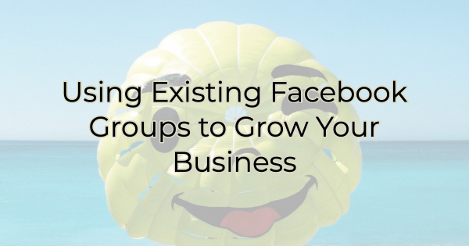

Facebook groups are an excellent way to grow your business. Here are a few ways to do this in an existing group.

Grow Your Business Through Existing Facebook Groups

Do Your Research
First, do your research. As mentioned previously some groups are owned by people with their own agenda. It's important to know who's behind the group you want to join. For instance, if you're a real estate agent looking for more clients, it doesn't do you any good to join a Facebook group started by another real estate agent. Chances are, if you offer your information in a salesy way, you'll be kicked out of the group. Knowing the organizer behind the group is essential to your success. When it comes to local groups people start them for a host of different reasons.

Understand the Rules
Some groups let you post about your business 24/7. Other groups have a specific day designated for business posts. Finally, other groups have a no solicitation policy. If you want to be successful in your Facebook group of choice make sure you read and understand the group’s rules.

Update Your Bio
Before interacting on any Facebook group, you want to make sure that you've updated your bio on both your business page and your personal profile. It used to be that you could only join a group from your personal profile. That’s no longer the case. In some instances, you can join from your business page. If both are allowed, you'll need to decide which one works best for you.

Since people do business with people they like there's a benefit to joining from your personal profile. However, if you choose to do this, you need to make sure that your company is referenced on your personal profile’s bio. Otherwise, people won’t make the connection between you and your business.

One point to consider when deciding between joining from your personal profile or your business page is that if you share a lot of things on your personal profile that may get in the way of you doing business, don't join this way. If on the other hand, you decide to join from your business page, make sure your business page is congenial and welcoming. Because if people find your posts helpful and they're in need of your services or products, they can click on your response and go to your page directly. For maximum lead potential, your page must be ready to welcome potential customers.

Do Your Research (Again)
Spend some time reading over posts and get a better understanding of what people in the group are looking for. Pay close attention to the types of posts that get a lot of positive engagement. While you may be joining the group to increase sales for your business, if you find out that sunset posts, for instance, reign supreme from an engagement perspective, then start there. (How about a picture of the sun setting from your business?) Post what people love and as they get used to seeing your name they will make positive associations with your business.

Educate, Entertain, or Inspire but Never Sell
OK, never might be a little too heavy-handed, but most people aren't on Facebook because they want to hear how amazing your business is. If someone specifically asks for the kind of products or services you offer, join the conversation, and explain what makes you unique. Or better yet have a local friend who is on the group provide a referral to your business.

But for most posts you're going to want to refrain from speaking about your business. Instead, showcase your knowledge in a helpful way, point people in the right direction, refer people to other businesses in town that you enjoy, and do your best to be a part of the conversation.

In addition to refraining from being overly salesy, you also want to stay away from jumping on the bandwagon when someone puts another business down even if it's your competitor. Especially then. Nothing good can come out of your name being associated with negativity about the community.

Finally, just have fun. Let people get to know you, share things about the community that you love, give positive reinforcement and suggestions, and show up on a regular basis. People get to know you that way and are more likely to do business with you in the future. Remember, social media is about relationship building. That takes time. You don't want to join a group and immediately start talking about yourself, your business, and only the things you care about. You're there to add to the conversation, not to appear with a megaphone announcing yourself. Consistent, helpful participation is the way to get interest in your business. And interest is the first step toward eventually landing the sale.

Christina Metcalf is a writer/ghostwriter who believes in the power of story. She works with small businesses, chambers of commerce, and business professionals who want to make an impression and grow a loyal customer/member base. She loves road trips, hates exclamation points, and believes the world would be a better place if we all had our own theme song that played when we entered the room. What would yours be?
_______________________________________
Twitter: @christinagsmith
Facebook: @tellyourstorygetemtalking
LinkedIn: @christinagsmith

