Unwrapping the Power of Holiday Email Marketing

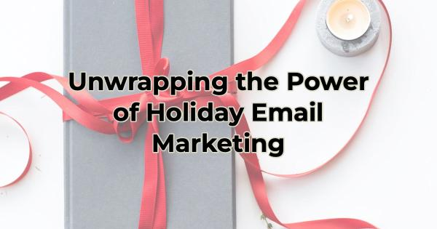

The holiday season is not just a time for festive decorations and warm gatherings; it's also a golden opportunity for you to expand your reach and build a loyal customer base that you can market to interact with all year long. One effective way to achieve this is by leveraging the power of email marketing. After all, the holidays are the perfect time to build an email list because everyone is looking for value and savings. Building a list now can significantly benefit your business in the long run.

Email Marketing Quick Tips
Marketing gurus will tell you that marketing is about touchpoints and many channels offer that possibility, but email marketing is the best way to make a sale. But it’s not a short race. It’s a long-term relationship building method that yields great results. It’s nothing to dabble in. To make thousands of dollars from your email marketing, you need to give, give, give and there’s no better time to start giving than the holiday season.

During the holidays, people are more active online as they search for the perfect gifts, explore holiday deals, and plan celebrations. This heightened online presence provides you with a unique chance to capture the attention of potential customers and encourage them to subscribe to your email list.

Here’s a quick and dirty summary of how you can build a list and leverage it to drive revenue throughout the upcoming year and beyond.
If you need a little more explanation about the tech and components you’ll be using, this article is a good place to start.

Produce Engaging Holiday Content
The holiday season is the perfect time for creating engaging and relevant content. Whether it's festive newsletters, exclusive holiday discounts, gift guides, or seasonal promotions, your email marketing campaigns can stand out and resonate with your audience. By offering valuable content, you'll entice visitors to subscribe to your email list to stay updated on your special holiday offerings.

Offer Incentives and Giveaways
People love freebies and special offers, especially during the holidays. Use this time to create irresistible incentives for joining your email list, such as exclusive discounts, holiday-themed downloadable content, or entry into a festive giveaway. The allure of these incentives can drive more sign-ups and set the stage for long-term customer engagement. Make sure you create and suggest email sign-ups for your online and in-person audiences.

Build Relationships
Let people get to know you through what you share. Use your email campaigns to share the story of your brand, express gratitude to your customers, and showcase the values that make your business unique. Slip in a cute picture of your pet while you’re at it. By establishing a personal connection, you'll encourage subscribers to stay engaged.

Segment, Segment, Segment
As you gain subscribers, you'll have the chance to segment your email list based on things like preferences, purchase history, or location. This segmentation allows you to send more targeted and personalized content, increasing the relevance of your messages and ultimately driving higher conversion rates. For instance, if you haven’t heard from one of your loyal customers in a while, send them a “We miss you” discount to bring them back in.

The Gift That Keeps on Giving
Do you know the answer to when is the best time to plant a tree? Twenty years ago. What about the second best? Today. The same can be said about starting to build your email list. The best time to do that was last Christmas or the one before or the one…well, you get the idea. The second-best time is now.

With a robust email list, you have something that is yours and you use it to significantly boost your sales and conversions well into the future. However, while an email list is the gift that keeps on giving, you must also be prepared to give and give and give. Provide your audience with valuable information, content, and entertainment FOR FREE, over and over. Once you do this, and help them get to know, like, and trust you, you can occasionally ask for something from them in return.

Think of this relationship like one between a parent and a child. As the parent, you are going to give so much more than the child does. The relationship (at least in the beginning) will seem lopsided and you might be tired of everything you’re doing for them. But as the relationship matures, you will feel the love returned and be the better for it.

Christina Metcalf is a writer/ghostwriter who believes in the power of story. She works with small businesses, chambers of commerce, and business professionals who want to make an impression and grow a loyal customer/member base. She loves road trips, hates exclamation points, and believes the world would be a better place if we all had our own theme song that played when we entered the room. What would yours be?
_______________________________________
Twitter: @christinagsmith
Facebook: @tellyourstorygetemtalking
LinkedIn: @christinagsmith

