Stop Procrastinating Tomorrow

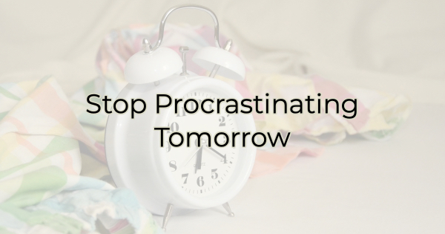

The title of this article is supposed to be funny, but procrastination isn’t a laughing matter. In fact, procrastination can be severely impacting your business. It can affect sales, revenue, and employee happiness. But when work is tough and no news sounds good, it’s easy to tell yourself that you’ll handle the hard stuff on a better day. The problem is there will never be a perfect day to do the hard things. So, here’s how you can tackle today, what you could put off for tomorrow.

6 Ways to Stop Procrastinating
Procrastination is an excellent way to miss opportunities, and no one wants that. If you’ve found yourself procrastinating a lot recently, it’s time to get it under control. Take back your tomorrow, and get things done today with these tips and mental shifts.

Get Control
“I just don’t feel like it” is a common nagging feeling for many people these days. Feeling overwhelmed by the level of work, the high cost of living, and a dozen other worries, it’s easy to put things off. But most of those things won’t go away. You need to shift your mindset from one of passivity to one of action. Tackling the hard stuff will give you a sense of accomplishment and make you feel like you are back in the driver’s seat again.

Make a List of What Needs to Be Done
Make a list of the absolutes—the things that cannot be put off any longer. Use whatever format you love, whether that’s a paper to-do list or an app. For me, there’s something rewarding about using a highlighter to cross off what I’ve accomplished. But some people like the convenience of having the list on their phone.

Figure Out How You Work Best
Next, decide if you are the type of person who wants to start your day off accomplishing several small tasks quickly or the largest/hardest one first. I like to gain traction in the morning by tackling a few easy wins. I also go for the easy wins when I know I have a hard stop like a meeting. I don’t want to start something large knowing I’ll get interrupted.

However, you may find you like to tackle the big things when you are fresh. You may also come to realize that you like working on a big project when you know you have a hard stop because you enjoy a break and the distraction of doing something else. Learn these things about how you like to work and implement strategies around them.

Recognize Your Self Deception
Why do you put things off most often? Do you put off big tasks because you feel overwhelmed, or do you put off small tasks thinking you shouldn’t be wasting your large chunks of time now and will do them later? Some people put off small tasks because they figure they don’t need much time to complete them. They tell themselves they’ll do the small tasks in front of TV in the evening or multitask while in carline, running errands, or attending a function.

Determine your most common excuse and address it. Stop giving yourself outs. For instance, if you shy away from large projects because they’re intimidating and tell yourself you’ll do it when you have more time, know that there is no time like the present. You can only speak to the amount of time you have currently. Tomorrow’s time may be spoken for. It’s not guaranteed, after all. Also, you may realize after starting the project that it is not nearly as daunting as you expected.

Take One Bite at a Time
Since most of us tend to procrastinate the big projects, another way to combat that is by breaking big projects into smaller segments or bites. As you check off each of the smaller segments, you’ll feel more accomplished and build momentum. Plus, smaller bites provide you with natural stopping points so you can switch gears or take a break and come back refreshed.

Give Yourself a Deadline
It’s easy to table things that don’t have a deadline, especially if most of your work is deadline-driven. When that happens the pieces that don’t have deadlines get lost in a pressured environment. Whether you are assigning the task to yourself, or someone is assigning it to you, make sure everything in the pipeline has a deadline. That way, it is less apt to be set aside.

Procrastination can make you miss out on a lot with your business, but it can also make you feel plagued by guilt, anxiety, and a feeling of underperformance or underachievement. Conquer what you are putting off today so that you can feel more empowered and closer to your goals.

Christina Metcalf is a writer/ghostwriter who believes in the power of story. She works with small businesses, chambers of commerce, and business professionals who want to make an impression and grow a loyal customer/member base. She loves road trips, hates exclamation points, and believes the world would be a better place if we all had our own theme song that played when we entered the room. What would yours be?
_______________________________________
Twitter: @christinagsmith
Facebook: @tellyourstorygetemtalking
LinkedIn: @christinagsmith

