Should I Use AI for My Business?

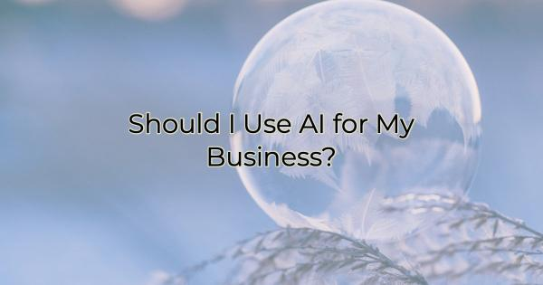

AI is certainly the “Belle of the Ball” these days but it’s also coming under scrutiny. It can save businesses a lot of time, but many professionals are afraid of what the adoption might mean. Is it right for you and your business?

First, unless you are off the grid, you’re likely already using AI for your business. If you use a grammar check, you’re using AI. If you’re employing a voice assistant or navigational assist, you’re using AI.

“AI” is a catch-all term for a host of business tools and capabilities. There are platforms like Bard and ChatGPT that can perform anything from parlor tricks of asking it fun questions and enjoying its answers, to much more complex analysis through enterprise systems. Asking whether you should use AI is a bit like asking, “should I take transportation to get to my destination” when you’re already on a scooter. The answer depends on where you’re going and what method (of transportation) you are asking about. For instance, if you want some new website copy, you don’t need an enterprise AI system. The free version of ChatGPT is fine (with your guidance, of course).

Whether you should use AI depends on various factors, including the nature of your business, your specific goals, budget, and the resources you have available. Here are some considerations to help you decide:

Considerations in Using AI for Business

Business Objectives
First and foremost, consider how AI will align with your business objectives. AI can be used for improving efficiency, automating tasks, enhancing customer experiences, making data-driven decisions, and helping you do more with your limited resources.

Competitive Advantage
Evaluate whether AI can give you a competitive edge. In some industries, AI can be a game-changer, enabling you to offer better products or services, optimize processes, or gain insights that your competitors may not have. In other industries, it might be best used as a search engine or preliminary content creator.

Data Availability
AI relies on data. If you’re going to have it analyze anything for you, then you need to have access to relevant, high-quality data to train and deploy AI models. If you lack the necessary data, you may need to invest in data collection and management first.

Budget
AI development and implementation can be costly. Consider whether your business has the budget to invest in AI, which includes expenses for software, hardware, talent, and ongoing maintenance.

Skill and Expertise
Building and deploying advanced AI solutions require expertise in machine learning, data science, and software development. You can hire AI professionals, outsource the work, or seek AI platforms and tools that require less technical expertise. Your ultimate desired results will shape the forms of AI (the scale and complexity) that you require.

Regulatory and Ethical Considerations
Depending on your industry and location, there may be regulations and ethical considerations related to AI usage. Some countries have banned it or regulated its usage. The Biden administration has voiced some concerns over ensuring digital safety.

Return on Investment (ROI)
Some AI is free while some requires a minimal investment ($20 per month). Other types of AI require major company initiatives. There’s an entry point for every business and budget. Evaluate the potential ROI of implementing AI. How will it impact your revenue, cost savings, or customer satisfaction?

Risks
AI is not always right. If it doesn’t know the answer to your question, it won’t reply that it doesn’t know. It will find the closest answer it can. That means using this tool comes with uncertainties and risks. Question responses, edit copy generated by AI. Speaking of risks, let’s talk about a few cons before you decide on adoption.

The Cons Behind AI

These are all solid points and questions you can ask yourself when deciding to implement AI on a beginning or more robust scale. However, it’s important to note that AI is not without its cons. Content generated by AI is not protected by the US Copyright Office. The creators of platforms like ChatGPT are also quick to point out that mistakes (or hallucinations as many industry people call them) can happen when asking it questions or having it create content. It’s not great at stats or dates, sometimes even quotes (sort of like that best friend who knows a little bit about everything and occasionally says something where you question their source).

Some large companies have blocked internal ChatGPT use (for instance), including JPMorgan Chase, Apple, Verizon, Spotify and Accenture, according to AI content detector Originality.AI, with several citing privacy and security concerns. Additionally, Italy was the first western nation to ban ChatGPT citing that it was easier to ban it than regulate it. Business leaders have also expressed worries about employees keying proprietary information into ChatGPT and their sensitive information emerging as an output by the tool elsewhere.

Should you use AI in your business? Unless you’re making a conscious decision to avoid it, you probably already are. But how much of your operations are machine driven is a choice. While you may not be ready to jump on the AI bandwagon fully, there are a lot of business efficiencies it can help you with. Creating copy and written communications is one of these areas. But just as you wouldn’t place a plank of wood in front of a circular saw and expect a house from it, you need to guide the process to create exactly what you’re looking for.

Christina Metcalf is a writer/ghostwriter who believes in the power of story. She works with small businesses, chambers of commerce, and business professionals who want to make an impression and grow a loyal customer/member base. She loves road trips, hates exclamation points, and believes the world would be a better place if we all had our own theme song that played when we entered the room. What would yours be?
_______________________________________
Twitter: @christinagsmith
Facebook: @tellyourstorygetemtalking
LinkedIn: @christinagsmith

