Popular Misconceptions About Shopping Small That Are Holding Your Customers Back

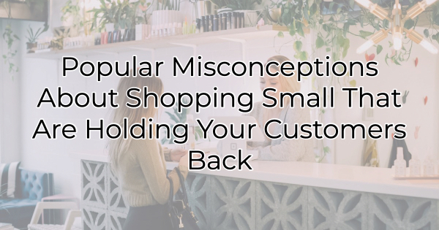

As I'm writing this, we're closing in on two weeks until Christmas. That means businesses with e-commerce options are quickly counting down deadlines for Christmas deliveries. This is the perfect time for local small business to shine because you can promise customers holiday smiles quicker than they can be delivered in online purchases. However, there may still be things holding the average customer back. Questions lead to inaction. To overcome some of these misconceptions about shopping with you, you'll want to tackle them head-on. Here are some of the most common concerns that are likely holding your customers back and how you can address them.

Common Misconceptions about Shopping Small

It's More Expensive
While small businesses often don't sell the loss leaders that big retail companies do, small does not equal expensive. Large retailer’s pricing is set on a national level factoring in national costs of living. This is particularly true online. However, a local small business is going to set prices based on its economy, not New York’s or Los Angeles’. That means the cost of things is in line with what the market sets in your community.

What you can do to combat this myth: in addition to talking about affordability, make sure everyone knows that when they buy from your small business more money stays in the local economy.

They're Never Open
Some people would rather shop with a large business because they know when the store is open. Many local businesses stay open later right before the holidays, but people won't know if you don't tell them.

What you can do to combat this myth: Make sure you post your hours on social media and your business profile on Google. If shoppers have any questions about whether you'll be open or not, and they perform a quick search, they should be able to see when they can shop with you. If your hours are impacted by the holiday, make sure you communicate this online on your website, on your Google business profile, and social media, as well as notifying people with signs on the door and in your business.

Selection Is Limited
Again, the selection in a small business will never be as large as a giant warehouse but that's not where the appeal lies. The beauty of a small business is that you find those unexpected items. The ones you will be proud to gift because they're not found on every shelf. You can match your gift to the recipient in a way that is almost magical when you shop small.

What you can do to combat this myth: If there's an in-demand item in your town and you have a few, make sure you post that to social media and update people when you sell out. Aside from that, share the unique items or services that you sell so people who are scrolling through their social media posts will be moved to act and come visit you. While large retailers carry a lot of the same things, people won't know what you carry if you don't share it with them. Your social media profiles, along with your website, are ideal places to get attention for the wonderful items and services you have to offer.

As the small business season wraps up over the next few weeks, small businesses are at an advantage. You can provide easy access to unique gifts and services as well as help with last-minute gift ideas. Those looking to get in the holiday spirit can't do it online so providing them with an invitation to check out your business can go a long way to bringing in new customers. If you want them to act, just think about what may be holding them back and provide them with the information they need to overcome those misconceptions.

Christina Metcalf is a writer/ghostwriter who believes in the power of story. She works with small businesses, chambers of commerce, and business professionals who want to make an impression and grow a loyal customer/member base. She loves road trips, hates exclamation points, and believes the world would be a better place if we all had our own theme song that played when we entered the room. What would yours be?
_______________________________________
Twitter: @christinagsmith
Facebook: @tellyourstorygetemtalking
LinkedIn: @christinagsmith

