AI for Business: Bewares and Boasts
Practical ways to use it in business and what to avoid

At first glance, especially for people who have trouble writing or have difficulty starting out and collecting their thoughts at a keyboard, AI can feel like the smartest kid in the class offering to do your homework for free, forever. It seems like a huge win and I’m not saying it isn’t. But there are a few things you should be aware of as well as some tasks it does tremendously well that could save you a lot of time and energy.

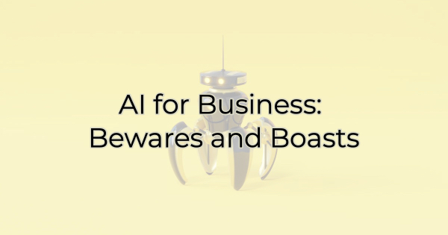

AI “Doesn’t Always Get It Right”
Google’s new Bard (AI) issued this statement to all users, “Bard will not always get it right.
Bard may give inaccurate or inappropriate responses. When in doubt, use the ‘Google it’ button to check Bard’s responses.” This is true of all AI. AI is not a sentient being. It gets its answers and content by crawling the web and condensing information. Sometimes that can cause problems.

It doesn’t:
- Fact check or verify stats and attributions/citations
- Sift out bad info (if that information is mentioned in a variety of places)
- Have any vested interest in producing SEO-rich content for you (unless you use an AI program that is created for that)
- Know what your audience responds to

AI Has Different Levels of Sophistication
There are many free options out there as well as AI/bot starters where you can build your own “in minutes.” It’s important to know that each one has different capabilities and claims—some have a plagiarism detector, for instance, so you needn’t worry about the copy it creates for you being flagged as duplicate content.

It’s Only as Good as What You Feed It
The real benefit of using AI lies in its ability to create content in a fraction of the time it takes for a human to write it. Even talented writers using dictation software or ones blessed with 100+ words per minute typing skills, can’t research and write a 300-word blog post in a minute.

But the content is only as good as the instructions you give it. For instance, if you were producing a blog post about Golden Retrievers, as a dog walker your blog would be different than that of a dog breeder/dog show participant, which would be different still from a vet’s perspective written for other vets. The level of sophistication and knowledge is different for each of those audiences. You will need to express that in the directions you provide the AI if you want a good piece of content that fits the needs and understanding of your audience.

AIs Struggle with Same Names
When I asked Google’s AI Bard what Bard does really well as research for this article, it responded with things that a bard/storyteller excels at, not what it does. (However, when I asked “what do you do well?,” it provided a satisfactory answer.

So, if your business shares a name with something else or you’re using a play on words or employing a name/word in a different context, the program may not produce helpful results.

5 Things AI Does Well
Now that you know what to watch out for, let’s cover a few things it does really well. Using AI for these things can save you lots of time.

- Help you brainstorm. If you’re rewriting your business tagline and you have part of it but can’t think of the perfect ending, try giving an AI writer a prompt such as, “help me finish my <insert type of business> tagline <insert what you have so far>.
- Come up with invite language. Basic invite language is a breeze for AIs. Canva has one built in.
- Write simple emails or letters. Creating form letters can be a pain but not with AI. Feed it the necessary info and you can move on to a better use of your time.
- Create an org chart. Provide your positions and it will give you what you need.
- Produce content without colorful language. Many writers lament that the content AI creates is boring. It lacks colorful language and stories. While it can create stories for you, it won’t add a story example to a blog post. However, “boring” is not always bad. If you want to create content that lacks biased language AI might be the way to go. Don’t ditch your editor yet but I have not come across any use of language bias when employing an AI assistant.

Is using AI right for you and your business? Perhaps. But keep in mind, it is a tool, not an additional employee. It can produce content in a fraction of the time, but it requires oversight. It does not always generate content ready to be used as is. If you envision what it creates as a starting point product like how a sous chef does the prep work for a top chef, you have a good understanding of how you might use it in your business.

Christina Metcalf is a writer/ghostwriter who believes in the power of story. She works with small businesses, chambers of commerce, and business professionals who want to make an impression and grow a loyal customer/member base. She loves road trips, hates exclamation points, and believes the world would be a better place if we all had our own theme song that played when we entered the room. What would yours be?
_______________________________________
Twitter: @christinagsmith
Facebook: @tellyourstorygetemtalking
LinkedIn: @christinagsmith

