9 Success Strategies for Young Businesses

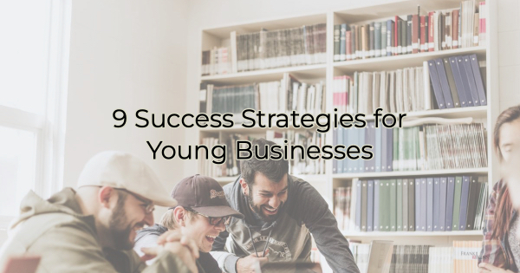

Launching a business is a thrilling journey filled with possibilities and challenges. While no year is without challenges, the first few are particularly so for most businesses. Many naive owners think that if they can make it through the first year, their success is guaranteed. However, that isn’t the case. The first year actually has the lowest failure rate. According to the Bureau of Labor Statistics, approximately 20% of small businesses fail within their first year. The failure rate increases to 30% by the end of the second year, 50% by the fifth year, and 70% by the tenth year.

That’s because there are challenges beyond bringing in customers. The main challenges (reasons businesses fail) like cash flow problems, lack of demand for the product or service, and insufficient capital in addition to sustaining growth while staying relevant in a competitive landscape, can make starting a business exciting and daunting.

But you don’t have to go it alone. Your chamber of commerce is a wealth of resources for your new business and can help you with some of the ideas below.

9 Success Strategies for New Businesses
Here are some strategies tailored to boost success for new businesses:

Embrace Community Engagement
Your local community is a goldmine of potential customers and supporters. Engage with them beyond just transactions. Host workshops, seminars, or events relevant to their needs. For instance, if you're in the wellness sector, offer free yoga sessions or health talks. Not only does this establish you as an authority in your field, but it also fosters a loyal customer base that feels connected to your brand.

Leverage Digital Platforms Wisely
Spend time cultivating a strong online presence and making an impact. Tailor your social media content to resonate with your audience. Share behind-the-scenes glimpses, customer testimonials, or even collaborations with other small businesses in your area. Have fun with your audience. Ask them questions. This creates a sense of authenticity and community, enticing customers to support a local brand they can relate to.

Prioritize Customer Experience
Exceptional customer service is a timeless strategy for success. Aim to go above and beyond in satisfying your customers. Providing good customer service is simply meeting an expectation. You want to exceed it. Personalize their experience, whether it's remembering their names or their preferences. Implement loyalty programs or exclusive perks for returning customers. For example, you could implement a “hometown” discount card for locals to encourage people to dine with you year-round instead of just during high traffic times. A happy customer is not just a one-time sale; they can become your brand's advocates, bringing in more business through word-of-mouth referrals.

Collaborate for Mutual Growth
Forge partnerships with other local businesses. Consider cross-promotions, joint events, or bundled offerings. For example, if you run a local wine bar (and don’t serve food), collaborate with a nearby restaurant on ways you can bring their menu to your establishment, possibly through discounted delivery service. Or offer a “wine and dine” discount or special deal for customers visiting both establishments. Such partnerships increase your reach and introduce your brand to a wider audience.

Continuous Learning and Adaptability
The business landscape is dynamic, and agility is imperative to survival. Stay updated with industry trends, attend workshops (your chamber probably offers very affordable learning opportunities), or enroll in online courses related to your field. Embrace change and be open to pivoting your strategies based on feedback and market shifts.

The pandemic forced us all to evolve, but proactive flexibility and a willingness to evolve/innovate can set you apart from competitors and help your business thrive.

Invest in Technology
Invest in technology that will help make you more efficient. New businesses often have struggles with cash flow and recognition. Hiring a full staff may not be in the budget so use technology in ways that help you do more with less. If you’re not a tech guru, take some time to educate yourself about what’s out there or talk with people at your chamber. The staff there (as well as the members) can help you uncover affordable technology that will provide a good return on investment.

Sustainability and Social Responsibility
Consumers increasingly appreciate businesses that are environmentally conscious and socially responsible. Incorporate sustainable practices into your operations, whether it's reducing waste, using eco-friendly materials, or supporting local charities. Highlight these initiatives in your marketing efforts to attract customers who align with your values.

Cultivate a Strong Brand Identity
Your brand is more than just a logo; it's the essence of your business. Invest in building a cohesive brand identity that resonates with your target audience. From your website design to packaging, ensure consistency in conveying your brand's story and values. A strong brand identity fosters trust and recognition, essential for long-term success. Plus, many consumers look a business up online prior to visiting it. You want a website that invites them to visit and says you’re worth the trip.

Track and Analyze Performance
Utilize analytic tools to track your business performance. Monitor metrics like customer acquisition cost, conversion rates, and customer retention. Analyzing these data points helps in understanding what strategies are working and where improvements are needed. This data-driven approach enables you to make informed decisions and optimize your efforts for better results. If you are unclear on what metrics to track or how to do it, consider finding a business mentor.

The journey of a young business can be thrilling, challenging, and sometimes terrifying. While it’s true that only 25% of new businesses make it to 15 years or more, by engaging your community online and off, prioritizing extraordinary customer experience, collaborating with other businesses, continuously learning, being socially responsible, cultivating a strong brand, and tracking performance, you can build a solid foundation for year-round success.

These strategies create a roadmap towards sustainability and recognition within the local market. As the saying goes—success is a journey, not a destination. Consistent implementation of these strategies can pave the way for a flourishing enterprise. With these strategies, and a little luck, you may find yourself in the 25% who succeed through the long haul.

Christina Metcalf is a writer/ghostwriter who believes in the power of story. She works with small businesses, chambers of commerce, and business professionals who want to make an impression and grow a loyal customer/member base. She loves road trips, hates exclamation points, and believes the world would be a better place if we all had our own theme song that played when we entered the room. What would yours be?
_______________________________________
Twitter: @christinagsmith
Facebook: @tellyourstorygetemtalking
LinkedIn: @christinagsmith

