6 Ways to Make Your Business Stand Out During a Local Event

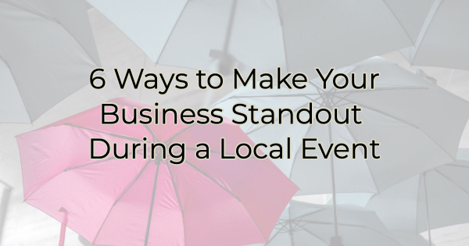

Does your town host a Wine Walk, Holiday Stroll, First Friday, or other downtown event where they close off streets and encourage people to get out and support business? If so, you may know that those events often bring the crowds but also bring “tire kickers,” people who are just out for a stroll, not really interested in what you sell. They’re just going into each business, poking around, and usually leaving empty handed.

The hard part of that is that you likely brought in full staff to ensure you had enough coverage only to deal with a lot of “lookers.”

But it doesn’t have to be that way. Here are a few suggestions on how to transform your looky-loos into looky heres.

6 Ways to Help Get the Sale
If you have an event that will bring a lot of commerce “tourists” to your business who do a lot of visiting and not much buying, you need to change that with these ideas.

- Tell a story. While you may not have the time to do this for everyone in the store, if you see someone eyeballing one of your items in a loving way, go up to them and tell them something interesting about the piece. You’d be surprised what may inspire a sale.
- Give a taste. If you sell food or drink, offer someone a taste before they buy. This works to create a sale in two ways: they’ll (hopefully) enjoy it and want more and/or because you kindly gave them a taste (and did something for them), they will feel obligated to buy from you.
- Teach a quick skill or use for your product. Draw the crowd into a quick presentation that features a product you sell. Have several products to hand people who want to buy right there. Alternately, have a pro available to answer questions. For instance, a store that sells painted furniture might have an expert on hand to walk people through how to do it themselves. Don’t worry that it will discourage them from buying from you. When they realize how hard it is, they will beg you to take their money.
- Get people on your mailing list. You never know when a “tire kicker” may see something in store and decide later that week they must have it. When people are in your store, ask them to join your mailing list. A few days after the event, follow up with a coupon, special offer, or sales notification. That call-to-action will likely send them your way.
- Offer a freebie for that night only. If it’s a special night or event, give away a little something to anyone who buys from you or offer specials for that night only.
- Create a singalong. In a crowded store, it’s hard to talk to everyone but you want to make sure people have fun and feel the energy of your business. You want them to remember you. A good way to accomplish that is by queuing up the tunes and encouraging people to sing with you. There are certain songs people just can’t help but sing along with—"Don’t stop believing.” You know what I mean. If you don’t, just put on Sweet Caroline and see what happens.

Christina R. Metcalf (formerly Green) is a marketer who enjoys using the power of story and refuses to believe meaningful copy can be written by bots. She helps chamber and small business professionals find the right words when they don’t have the time or interest to do so.
Christina hates exclamation points and loves road trips. Say hi on Twitter or reach out on Facebook.

