3 Creative Ways to Become Top of Mind

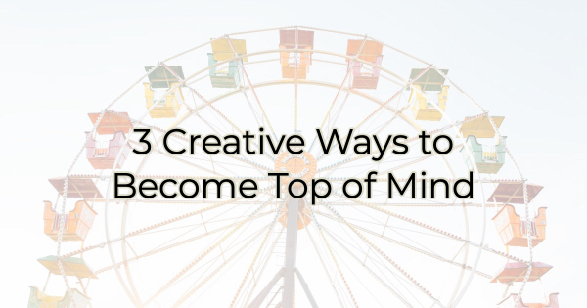

Do you want people to think about your business before all others? Of course, you do. The first step to patronizing your business is remembering it exists.

Imagine you have a free evening, and you want to go out to eat. It doesn’t matter how amazing the food is at the new place down the street; if it doesn’t pop into your mind, you won’t be going there.

The same is true of your potential customers. They need to think of you to spend money with you.

So how do you ensure you’re top of mind and that they will think about your business over the competition? You need to find a way to stand out and be memorable. A good product or service is the first step. Good customer service is also a solid choice. But to truly stand out you must do something slightly different.

Ways to Ensure Your Business Is Top of Mind

Events
Hosting an event at your business is a great way to help people remember you. It also provides an experience, and many individuals admit to enjoying them over physical purchases. When you host an event encourage people to share the occasion on social media for even greater reach.

There are several types of events that draw crowds:

- Sampling your offerings or services. You can host an event that is directly related to what you do. For instance, a restaurant may have an invitation-only, special tasting night to sample its new menu.
- Education event. You could also offer an evening out based around something that you sell. For instance, a yarn store may hold classes on how to knit.
- Block party. Celebrate your customers and potential customers by throwing a party outside your store. A patio furniture store held a parking lot party every weekend with a band and hot dogs. It drew a crowd and people lingered. It was a nice tie in with the product they sold—outdoor furniture. It helped people imagine hosting their own parties later with their new furniture.

A Facebook Group
Depending on the nature of your business, and the things your ideal customer/target audience may have in common, a Facebook group can connect your buyers to you and to one another. This idea works well when you can find a connection or mutual interest among your customers. For instance, a bookstore might create a Facebook group for writers or for fans of a specific genre. In a Facebook group you can share information and flash sales, stream events, and invite your audience to talk about their favorite books. The online community will keep your brand center stage while uniting and engaging your audience.

Savings Clubs/Subscriptions
Have you noticed that a lot of companies are charging their customers a monthly fee for some sort of discount or benefit? It began with Amazon Prime, where customers paid an annual fee for free shipping. The program has expanded beyond that now, but you can certainly start with one benefit like that.

Panera has created an unlimited coffee subscription where coffee lovers are auto-charged a fee each month and given a free cup of coffee daily. Both programs drive sales (and loyalty). When people pay for something, they want to get their money’s worth. Often, that means buying from one store over another because they're part of a savings club.

However, like gift certificates, there may be people who pay every month and don't use your services. That's OK too as the subscription (even if it’s only a few dollars) is a source of revenue you did not have before.

If you want strong sales at your business, you need to ensure that your target market thinks about you. You can do that through email marketing, social media participation, or these three ideas. But whatever you do, make sure you use consistent branding and tone. After all, you want them to remember you, not question who you are.

Christina R. Metcalf (formerly Green) is a marketer who enjoys using the power of story and refuses to believe meaningful copy can be written by bots. She helps chamber and small business professionals find the right words when they don’t have the time or interest to do so.
Christina hates exclamation points and loves road trips. Say hi on Twitter or reach out on Facebook.

