3 Storytelling Tips for Marketing a Boring Product/Service at the Holidays

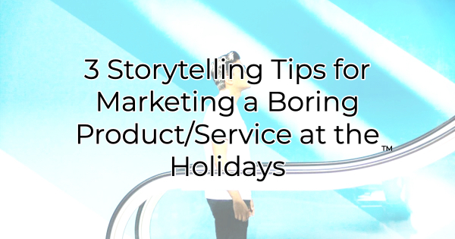

We’re not here to call your baby ugly. But let’s face it, if you’re reading this article, you must think your product or service isn’t the sexiest, easiest to market. But that doesn’t mean there isn’t good potential. Storytelling can help enliven even the most common products. Through these marketing suggestions you can finish the holiday season strong and carry that momentum through next year.

Storytelling Tips for Marketing Boring Products and Services

Find the Hero
Your product or service—no matter how (traditionally) uninspiring—helps someone. Just figure out who and how. For instance, if you own a 5-minute oil change business, it may not be the sort of thing people get excited about, but you offer a very convenient service.

Who do you help get back on the road quickly? Is it the busy mom running carpool or the executive salesperson between appointments? You are helping someone get back to what they’re meant to do safely and quickly. While they may roll their eyes at the need for getting their oil changed and put it off for several miles, your quick service makes a big difference in their day. Because of you, they can do something amazing. Tell their story.

Focus on What Your Hero Wants
Continuing with the value of story, think about what your hero/customer wants to do more than anything else. How do you assist with that? This goes beyond helping them with something they must do and revolves around what they want to do. That’s the stuff dreams are made of. For instance, your quick oil change means the busy mom is on time to pick up the kids, which is important on its own. But what she really wants is a few minutes before that to read a couple of pages of her favorite book. Your quick—in car—oil change gives her that coveted alone time providing a respite she secretly wishes could last a little longer.

You could have some fun with a holiday marketing campaign around that (escape from in-laws/family/out-of-town guests for five minutes, escape from responsibilities, etc). And it’s something a lot of people can identify with.

Sculpt Testimonials Around Your Stories
Once you have your hero’s story drafted, think about how you might use that to solicit testimonials. If you send out a customer survey, for instance, don’t ask the generic “how was your service.” Instead, ask “what did we help you escape from today?” or “how will you use the extra five minutes of your day?” These questions are unique enough to evoke a response. You likely will get some great stories for your testimonials.

The power of story makes anything more interesting. Look at what Tolkien did with a lost ring or Rowling did with school. It’s time you embrace the power of story outside of your “About Us” page.

Christina Metcalf is a writer/ghostwriter who believes in the power of story. She works with small businesses, chambers of commerce, and business professionals who want to make an impression and grow a loyal customer/member base. She loves road trips, hates exclamation points, and believes the world would be a better place if we all had our own theme song that played when we entered the room. What would yours be?
_______________________________________
Twitter: @christinagsmith
Facebook: @tellyourstorygetemtalking
LinkedIn: @christinagsmith

