Ten 2023 Trends Hand-picked for Small Business

Whether you sell food, things, or services, we’ve brought together a round-up of trends that you can incorporate into your business in 2023 for increased revenue and better market traction.

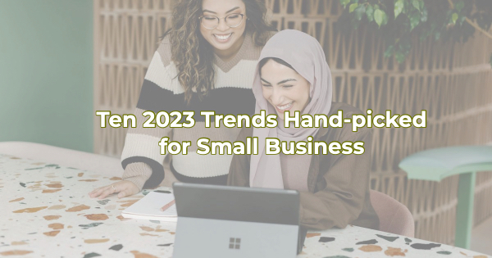

Ten 2023 Trends for Small Business

- According to Architectural Digest, kitsch is in. From vacation rentals to home décor, over-the-top is just the beginning.
- The New York Times proclaimed that climatarianism is the new Cabbage Patch Doll (what everyone wants and is willing to fight for – for those of you who didn’t grow up in the 80s). “It’s no longer about eating sustainably, which implies a state of preserving what is. A new generation wants food from companies that are actively healing the planet.”
- Creative employee incentives. The buzz around professional placement agencies is everyone wants to work from home. If you can offer that to your employees, great. But not everyone can. That's why we'll probably see a rise in creative employee incentives that will help offset the work-from-home benefit for companies that simply can't offer that.
- Going remote. This is not a new trend but it's likely because of the rising costs, we will see more businesses deciding to give up their physical space and support their employees going remote.
- Doing more with less. There are a lot of great technology options out there but not everyone can afford new technology. Many businesses will instead look for ways to maximize the technology they're currently using; working with the help desk or consultants to get the most out of their existing software and tech.
- Reducing paper. According to Inc., “It's time to actively reduce your company's carbon footprint. This can both save you money and engage clients and customers who prioritize environmental concerns.” A focus on the environment is becoming increasingly popular. Businesses that continue to use non-essential things like paper may find themselves on the wrong end of a public relations kerfuffle.
- Performance media. With the increasing usage of video platforms like TikTok, organizations will find that they are now in the business of performance media. People want to see personalities and humor in brand videos along with products and services. Go ahead. Roll your eyes. Then get to streaming.
- Creating a Cheers environment. For those of us who are old enough to remember this popular 80s sitcom, you can't hear the name Cheers without thinking of its theme song and the popular line, “…where everybody knows your name.” This type of familiarity is becoming an expectation for brands. Customers want to be remembered. This gives small business an advantage over the larger companies that can only do that virtually.
- Concentrate on supply chain security. While there are a lot of not-so-positive economic predictions for 2023, there is good news for local small business. Thought leaders like Forbes are warning, “Companies need to improve their resilience in any way that they can. This means reducing exposure to volatile market pricing of commodities, as well as building protective measures into supply chains to deal with shortages and rising logistical costs.” Local small business often relies on local suppliers so they may have an advantage with the supply chain. However, if you don't, you should consider how you will navigate continued shortages and Forbes’ prediction of rising logistical costs.
- Become more human. This has been a trend on New Year's lists for the past 10 years. But as many experts are predicting 2023 will be the year of digital transformation for many large companies, small companies can embrace their own secret weapon--humanity. While many companies combat hiring problems with an investment in mechanization, small businesses score big with what Forbes refers to as “… uniquely human skills that currently can’t be automated…skills such as creativity, critical thinking, interpersonal communication, leadership, and applying “humane” qualities like caring and compassion.”

Christina Metcalf is a writer/ghostwriter who believes in the power of story. She works with small businesses, chambers of commerce, and business professionals who want to make an impression and grow a loyal customer/member base. She loves road trips, hates exclamation points, and believes the world would be a better place if we all had our own theme song that played when we entered the room. What would yours be?
_______________________________________
Twitter: @christinagsmith
Facebook: @tellyourstorygetemtalking
LinkedIn: @christinagsmith

