Sprucing Up Your Website for the Holidays

Most people research online before they purchase. That could take the form of looking up prices, options, or educating themselves on the product or service they’re in the market for. Many buyers also use a business website to verify hours, availability, make reservations, etc. During the holiday season people are busier than ever and it’s common to check things out online before getting in a car. If your website isn’t easy to navigate, with important information front and center, you may be missing out on a host of customers. Here’s how you can ensure it’s in good shape.

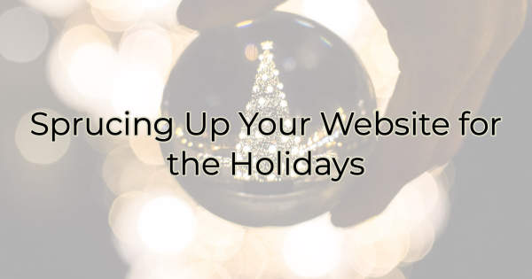

10 Things You Should Do Right Now for a Better Business Website
Most of the changes below are things you can implement quickly but you should also make sure that your website is user friendly, loads quickly, and looks great on mobile. If it doesn’t meet those requirements, work on those basics first.

Make sure you have the following things clearly accessible on your website:
- What you do and where you do it. This isn’t a mystery novel, it’s your business website. Make sure it’s clear to your audience what you do within the first few seconds of scanning. Remember some people will search for your site and they’ll want to make sure they have the correct business. Include your address, complete with city and state in a prominent place.
- Your hours. Your hours of operation must be visible and updated for the holidays. Don’t leave anyone wondering if you’re open. If you’re offering special holiday hours, call attention to that.
- Specials. Specials not only bring people in because of the increased value but they also make the website feel fresh and exciting.
- Ease. If there’s a well-known impediment to buying from you (such as finding parking in a crowded downtown), do your best to allay those fears or make suggestions on your site of how to work around them (like buying with you online or pointing out your delivery service). Change your content to reflect how easy it is to buy from you. That’s what people are looking for this time of year.
- Eye candy. If your business is decorated for the holidays, include pictures of that on your site. If not, create graphics on your specials that include holiday designs.
- Deadlines. If you offer online shopping or take custom orders, make holiday deadlines clear. Add a countdown clock or other bold notification of the deadline for the order to ensure Thanksgiving or Christmas delivery.
- The desired path for customers. Add content that solves a visitor’s problem and leads them to next steps (a purchase) such as a gift buying guide, how-to instructions for getting the best fit, etc. Highlight items or services in your business that fit common purchasing goals or needs like “perfect teacher’s gift” or “pamper yourself in a busy season with…”
- Good links. While you’re sprucing up your site, take a quick look at your links. Fix the broken ones. Bad links are frustrating for site visitors.
- Social sharing buttons. Social sharing buttons are a necessity year-round but especially during the holidays. Some online shoppers want to share the experience (and the deals!) with friends and family. Ensuring your content is easily sharable is the best way to encourage this and increase your audience.
- Video. Video helps people visit your business virtually, put a face with a name, and makes people feel like they know you, which feels very welcoming. Your videos do not have to be formal, high-production video ads. Many businesses are seeing success by simply filming 30-second walk throughs on new merchandise.

Prepping your business for the holiday season is essential but don’t forget your website while you’re at it. A stale website can make people wonder if you’re still open for business. And that’s no way to impress the holiday crowd.

Christina Metcalf is a writer/ghostwriter who believes in the power of story. She works with small businesses, chambers of commerce, and business professionals who want to make an impression and grow a loyal customer/member base. She loves road trips, hates exclamation points, and believes the world would be a better place if we all had our own theme song that played when we entered the room. What would yours be?
_______________________________________
Twitter: @christinagsmith
Facebook: @tellyourstorygetemtalking
LinkedIn: @christinagsmith

