Spooktacular Business Ideas for a Thrilling Halloween Season

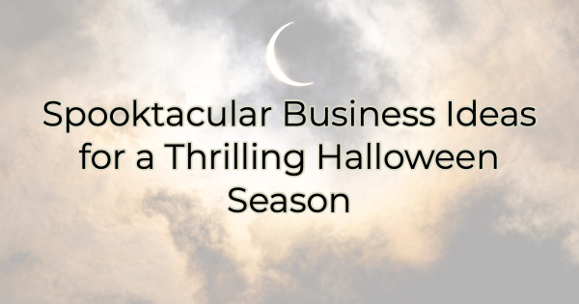

As the leaves turn golden and the air gets crisp, Halloween offers businesses a bewitching opportunity to embrace the spirit of the season and boost customer engagement. With a little creativity and a dash of spooky flair, you can draw crowds and appeal to your ideal customers. Here are some spooktacular Halloween-inspired ideas to help your small business shine during this spine-tingling season.

One note of caution: as in all marketing activities, it’s important to know your audience. A scary phantasma, for instance, would likely not appeal to small children just as talk of witches and devils may upset some adults. It’s important to understand your customers and celebrate accordingly.

Now, let’s get on with a ghostly good time.

Halloween-inspired Business Ideas

1. Haunted Happy Hours: Who said Halloween is just for trick-or-treaters? Host "Haunted Happy Hours" at your bar or restaurant, complete with spooky-themed drinks and appetizers. Encourage your staff to dress up in costume or host a costume contest for your patrons. Promote these events on social media and through your Chamber to attract the Halloween enthusiasts in your community. If your audience loves spirits, there are so many punny marketing options here.

2. Trick or Treat Extravaganza: If you have a physical storefront, turn it into a Halloween wonderland. Decorate your shop with cobwebs, skeletons, and pumpkins. Offer treats to visiting children and create a festive atmosphere that draws in families on their trick-or-treat adventures. This can be a great way to connect with your local community and leave a lasting impression.

3. Costume Contests and Workshops: If you run a clothing boutique or a costume shop, organize costume contests for your customers. Offer workshops on DIY costume ideas for those who want to get creative. This idea may seem like it interferes with business but it brings people in and they’ll likely buy something.

4. "Witchin' Workshops": Get your customers in the Halloween spirit by offering workshops related to your products or services. For example, if you own a bakery, host a pumpkin cupcake decorating workshop. A bookstore could offer spooky storytelling sessions, and a spa could run a Halloween-themed service concocting a special lotion mix. These workshops build a sense of community and loyalty around your brand.

5. Themed Sales and Discounts: Create Halloween-themed sales or promotions to entice customers. You can offer "spooky" discounts, such as 13% off or a "buy one, get one half off" deal. Decorate your website and social media profiles to match the Halloween theme.

6. Mystery Giveaways: Organize a series of mystery giveaways leading up to Halloween. Promote these on your social media platforms and encourage your customers to engage with your business online. Make the prizes Halloween-themed or related to your products and services, and the mystery element adds excitement and intrigue.

7. Spooky Decor and Selfies: Transform your business space into a Halloween haven and encourage customers to take photos in front of your spooky decor. Create a Halloween-themed backdrop and promote it as a perfect spot for selfies. Consider running a social media contest for the best Halloween selfie taken in your establishment.

8. Charity Events: Embrace the spirit of giving during this season of Halloween. Organize charity events like a "Trick-or-Treat for a Cause" campaign where a percentage of sales or specific products contribute to a charity. This not only promotes your business but also showcases your commitment to your community.

Halloween is a perfect time to infuse some fun and excitement into your small business. By leveraging the spirit of the season and offering creative and engaging events, you can draw a crowd and appeal to your ideal customers. Keep the atmosphere playful and spooky, not frightening for the widest appeal. Remember to tell the Chamber about your Halloween-inspired activities so they can help you get the word out.

Christina Metcalf is a writer/ghostwriter who believes in the power of story. She works with small businesses, chambers of commerce, and business professionals who want to make an impression and grow a loyal customer/member base. She loves road trips, hates exclamation points, and believes the world would be a better place if we all had our own theme song that played when we entered the room. What would yours be?
_______________________________________
Twitter: @christinagsmith
Facebook: @tellyourstorygetemtalking
LinkedIn: @christinagsmith

