Labor Day Ideas for Your Business

Labor Day is fast approaching. This unofficial end of summer is largely ignored by businesses partly because a holiday surrounding working doesn’t seem like much fun. However, you can use this day for more than planning a backyard BBQ or trip to the beach. Here are some engaging social media and activity ideas that you can work on over the next month to drive interaction and get employees and customers excited about this much overlooked holiday.

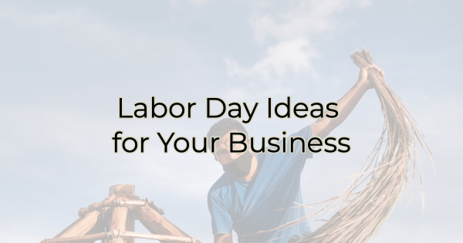

Labor Day Content Ideas
- Honor your employees for the hard work they put forth every day. Showcase them individually or as a group. Make them feel appreciated.
- Thank the laborers who have made our country what it is. Call out the quiet efforts that go unnoticed. Do a series of shoutouts to people who are essential to our lives.
- Call out the efforts of your vendors and suppliers. Name them. Tag them. Their audience will see your accolades.
- Feature local laborers in images like people working on the roads or construction nearby. Highlight a new project you’re excited about that wouldn’t be possible without their hard work.
- Send a Labor Day weekend message to everyone telling them you hope they enjoy this special time.
- Share a few funny pictures of your summer vacation or summer at your business. Say good-bye to summer.
- Ask your top performing employees to post about what person inspired them to be a hard worker.

Labor Day Activities
Posting to social media isn’t the only way to celebrate Labor Day. Here are a few ideas for your business.
- Treat employees to a BBQ and bring in lunch or let the managers cook for them in a parking lot cook off.
- Write a note or email to your staff about the year you’ve had so far and what you expect for the remainder of 2022. Keep it uplifting and inspirational.
- Close a few hours early to allow employees to get a jump on the weekend.
- Host a food contest such as a chili cook-off, best BBQ sauce, or best apple pie. Let employees and/or customers vote. Create a badge for the winner(s).
- Bring in an ice cream truck as a treat for your employees.
- Give a limited-time discount to all laborers like people in construction and other manual labor positions.
- Throw an all-white party (or invite employees to wear all white for the day) in honor of the old fashion rule of “no white after Labor Day.”
- Serve apple pie to customers.
- Run a contest for employees to see who can get the most positive business reviews.
- Ask customers to vote for their favorite employee. Let that employee go early the Friday before Labor Day weekend.

Labor Day Quotes
If you love inspirational quotes or you don’t want to come up with something on your own, that’s okay. Here are a few quotes from brilliant people that you could easily match up with an image or design it out for maximum impact.

“All labor that uplifts humanity has dignity and importance and should be undertaken with painstaking excellence.” – Martin Luther King Jr.

“It is labor indeed that puts the difference on everything.” – John Locke

"Before the reward there must be labor. You plant before you harvest. You sow in tears before you reap joy." ―Ralph Ransom

"There is no substitute for hard work." ―Thomas Edison

"All wealth is the product of labor." ―John Locke

“Far and away the best prize that life offers is the chance to work hard at work worth doing.” ―Theodore Roosevelt

Take these ideas and incorporate them in what works for your business. Labor Day is a great way to celebrate summer and your company’s efforts thus far. Have a safe and enjoyable Labor Day.

Christina Metcalf is a writer/ghostwriter who believes in the power of story. She works with small businesses, chambers of commerce, and business professionals who want to make an impression and grow a loyal customer/member base. She loves road trips, hates exclamation points, and believes the world would be a better place if we all had our own theme song that played when we entered the room. What would yours be?
_______________________________________
Twitter: @christinagsmith
Facebook: @tellyourstorygetemtalking
LinkedIn: @christinagsmith

