Efficiency Versus Effectiveness: which will you choose for 2022?

How do you like to work? Are you a speed or precision person? Do you like many small projects or one big, long one that you can dig into?

No, you’re not in the middle of a recruitment fair. These are simply questions that most self-aware professionals should know about themselves and about their teams.

My go-to answer used to be, “I can do either.” But that’s not really an answer, is it? What’s my preference? What do I excel in? After years of running my own business, I’ve come to realize that I like most of my days filled with many smaller projects, with a large one in the background that I can explore about once a week.

Because I like to go fast. What about you and your business?

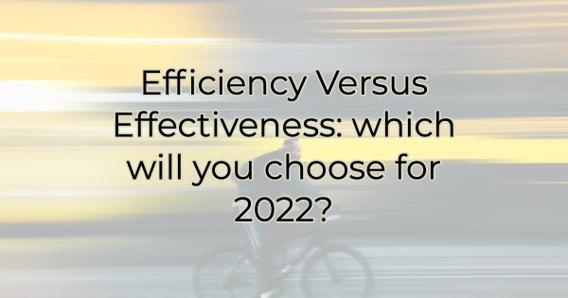

An Ode to Speed
I am always looking for more efficient ways to do things. Maybe you are too. There are tons of productivity tools, suggestions on how to streamline operations, and the like. If you love efficiency, you are probably a mass consumer of this type of content. You likely fill your time in the car with podcasts and maximize learning or working opportunities whenever possible. You also either fall asleep the minute you turn off the light or you’re up for hours considering new ideas and solutions.

If you work for someone else, they likely pass you the ball often because they know you’ll get it done on time but…

There’s something speed demons often sacrifice and that’s effectiveness. That’s not to say they aren’t effective at their jobs. But as they develop a reputation for getting things done, those around them pile on more. After all, it’s fun to watch kind of like those strongest man contests where they sport truck tires around their arm as if they were bangle bracelets.

Get It Done
Speed allows for singular focus. Efficient people know what tasks can be performed when. If they have a few minutes in their schedule, they know how to use them. Effective people, on the other hand, allow themselves to take a step back. To make decisions about what tasks will advance their ultimate goals and what will detract from them. They weigh everything against what they want to accomplish, and they say “no” often. They would rather have a moment doing nothing than cramming it full of busy work.

Effective people are not the most efficient. They are not the people you hand something to when it needs to be completed ASAP. They probably wouldn’t put up with you dumping things on them anyway. They make deliberate decisions.

Choose Your Way
As a business owner or employee, there are times to concentrate on efficiency and there are times to gear your operation to effectiveness. If you are one or the other all the time, you will find yourself struggling either with burn out or missed deadlines.

Ask yourself if this week you moved the marker toward your goals be being deliberate in what you were trying to accomplish, or did you break the speed barrier and astound audiences everywhere?

Only you know which of these is the most important for your business this week, this month, this year. But you must recognize the differences between the two to realize what you need when in order to succeed.

Christina R. Metcalf (formerly Green) is a marketer who enjoys using the power of story and refuses to believe meaningful copy can be written by bots. She helps chamber and small business professionals find the right words when they don’t have the time or interest to do so.
Christina hates exclamation points and loves road trips. Say hi on Twitter or reach out on Facebook.

