7 Things to Put Your Small Business on the Nice List

As of this writing, there are about three weeks left in the largest retail spending season of the year. If you own a small business and you want to ensure you bring in the most revenue possible in the next several weeks, there are a few things you must have in place. Just as Santa is making his list and checking it twice, you should do the same if you want to be on the “Nice List.”

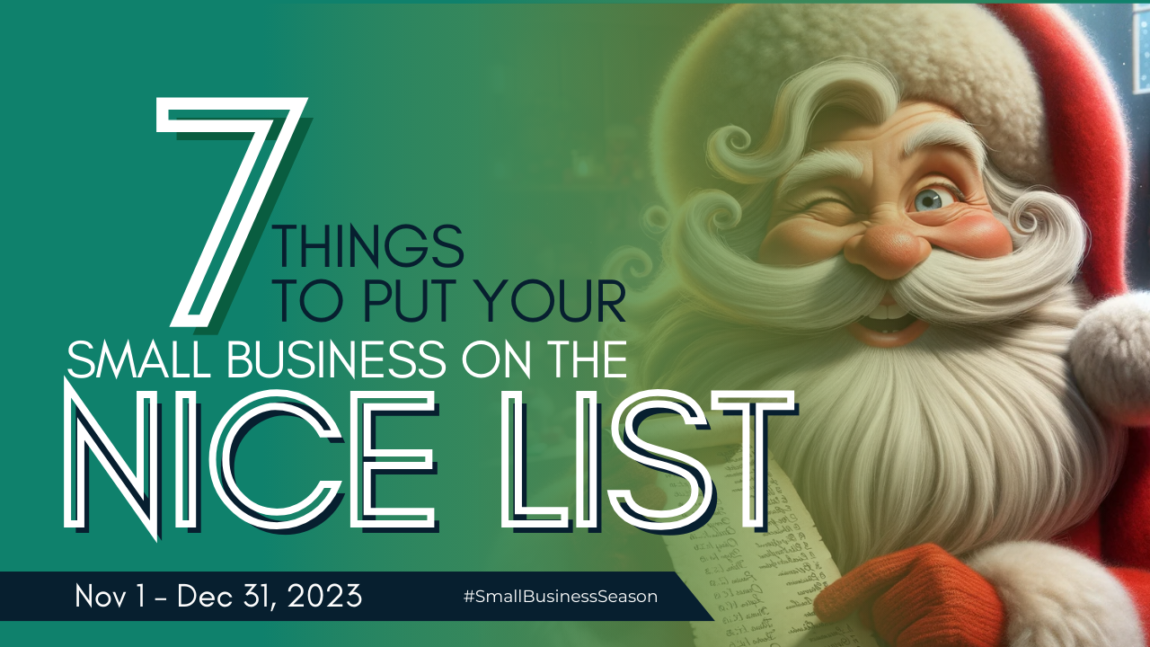

Getting on the “Nice” Business List
When we talk about things you need to make sure you do in your business, it really isn’t about naughty or nice in a moral sense. But some things just make it easier to buy from or work with you. Ensuring you meet the following qualifications will help you bring in more revenue before the end of the year.

- Stay open. People buy online because it works for their schedule. If you run a brick-and-mortar business and have limited or unpredictable hours, it’s hard to know when you’ll be open. If for only the holiday season, do your best to keep later hours and remain open more days of the week.
- By merry. If you’re trying to get people in the door of your business, make them feel welcome when they enter. You want to encourage browsing and repeat visits. Unfriendly manners or blank looks—or worse, staring at your phone—won’t bring them back.
- Make suggestions. Do a quick read on their purchases and preferences then offer suggestions on other things they might like. You could also strike up a conversation and ask them if they’ve completed their holiday shopping. If not, give them a few ideas for the people they still need to buy for.
- Offer unexpected discounts. If you’ve ever found money in a purse or a pocket, you know how good that can feel. When a business offers you a discount for no reason, it’s like winning the lottery. Pick a random person and give them a discount or watch for acts of kindness in your place of business and give the kind person something special like a bell ornament. It’s something people talk about.
- Help people get to know you. Using social media is important to bringing people in the door. It’s a great way to help people get to know and like you. Some businesses are also using it to sell and hire. Remember the infamous line from Hannibal Lecter in Silence of the Lambs, “People covet what they see every day.” When people get used to seeing you interacting on social media, they’ll begin to want what you’re offering.
- Send a thank you note. If they order online, include a special something in their package or wrap it in a beautiful bow. If they buy in person, throw a thank you postcard or sticker in with their merch (or leftovers). These little acts make a big impression.
- Consider what your audience needs most and give it to them. The most effective type of marketing that you can do is show how you solve a problem. For most retail businesses this time of year, that means providing the perfect gift. But you don’t have to be a retail business to cash in on some holiday spending. If you are a house cleaning business, point out that you have cleaning appointments still open before the holidays. Tell them how you can make their home perfect for guests with only a phone call. Frame your business in terms of how you can help make a stressful holiday easier, no matter what it is that you do because everyone could use more of that.

If you want your business to be on the “Nice List” this year, you need to do more than provide cookies. You want to find ways to connect with your audience. When you do, they’ll not only spend some of their holiday budget with you but also become loyal customers year-round.

