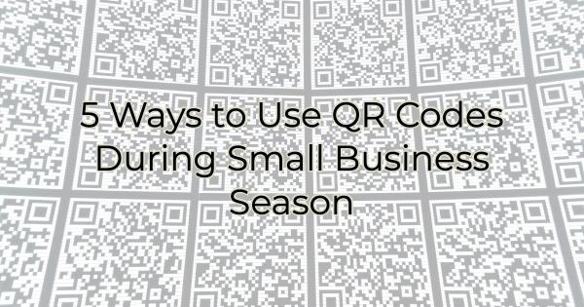

During COVID, QR codes made a comeback. They allow people to access important information without having to key in a URL. A QR code can also be used to reduce paper dependency and eliminate something people pass around such as a menu. QR codes reduce printing costs. That's why a lot of businesses are embracing them. However, there are times to use them and there are ways where they are more of a hassle. Follow these best practices in QR code usage during Small Business Season to make buying from you more appealing.

QR Code Usage Tip
Before we get into ways to use QR codes to promote your business, let's go over one practicality. Remember, QR codes must be scanned. Avoid using them anywhere that's difficult to scan. For instance, a billboard is an ineffective use of a QR code as it is difficult to scan while you're driving and 20 feet below. A website graphic is also not the best place to scan because you figure there is a good chance the viewer is viewing the QR code on their phone already. A URL is a better use of directing them to a website than a QR code in this example. Before adding a QR code to any of your marketing collateral ask yourself if its location will be easy to scan. If the answer is yes, add it.

5 Ways to Use QR Codes This Small Business Season

Window Clings or Signs on Your Business
If you have a brick-and-mortar location in a high pedestrian traffic area, using a QR code on your window cling or sign is a great way to bring people in. If you're a restaurant, having an easily scannable QR code link to your menu can help people see right away if they want to dine with you. You could also use a QR code to direct them to order online and take out. That way, they don't need to wait in line. You can also use QR code signage to advertise specials, holiday menus, or other information that will make it easier to buy from you.

Business Cards
If you attend a lot of events during Small Business Season, a QR code on your business cards can help interested people easily add your information to their contacts. It can also cut down on the number of cards you need to give out, saving money and the environment. That's becoming more important to people. You also can use a QR code on business cards to promote an evergreen special or direct them to a free consultation. QR codes can allow you to provide the business card recipient with more information without crowding your card design.

Review Sites
If reviews are important to you and your business (and they should be, especially during the holidays and Small Business Season when people are making a lot of purchasing decisions), place QR codes in waiting or lingering areas of your business. For instance, if you're a casual dining restaurant you can place a card on your table with a QR code to Yelp or other popular review sites. You have your customers’ attention as they dine with you. A QR code leads them easily to this site so they can leave a review.

Coupons
Using QR codes on a coupon gives you easy access to see how many people have used it. This important marketing information could make the difference in running that same coupon ad another time.

App Downloads
While going to the app download store of your choice seems easy enough, there are a lot of apps out there. That means you're asking your customers to find your app among many that could even have similar names to yours. A confused mind does not act. Instead, if you want them to download your app create a QR code that leads them directly there.

Using QR codes during Small Business Season can drive traffic and sales when used optimally. Keep in mind when implementing QR codes that the point is ease for your customers. If your code provides ease of access to information they want, they will use it, and you can track it.

Christina Metcalf is a writer/ghostwriter who believes in the power of story. She works with small businesses, chambers of commerce, and business professionals who want to make an impression and grow a loyal customer/member base. She loves road trips, hates exclamation points, and believes the world would be a better place if we all had our own theme song that played when we entered the room. What would yours be?
_______________________________________
Twitter: @christinagsmith
Facebook: @tellyourstorygetemtalking
LinkedIn: @christinagsmith

