5 Professionals You Need on Your Small Business Team

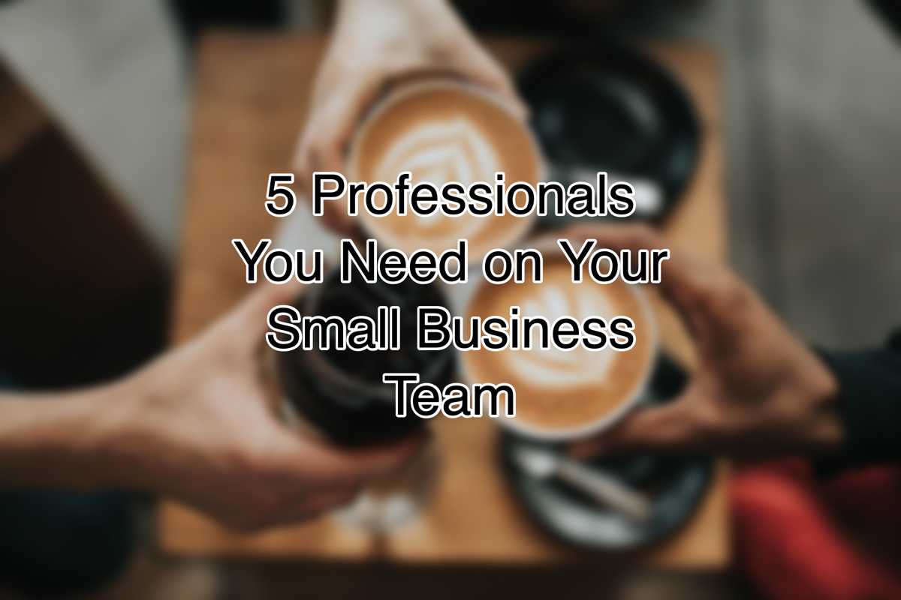

If you’re a small business owner without the resources to hire a large full-time team, you can still meet your business needs through freelancing or turning to independent business professionals. This can be an economical way to accomplish your goals without having to cover the cost of full-time employees.

5 Professionals Every Small Business Needs
Even if your budget is strapped, a successful business requires the services of the following types of professionals. These professionals do things that you don’t need to (or shouldn’t be doing on your own). They’ve spent years learning their trade and can help you avoid that costly learning curve or even costlier mistakes.

If you are ready to hire one of these people but you’re not sure where to find one, your chamber of commerce can help. The chamber knows a lot of professionals and can introduce you.

Lawyer
You don’t need a lawyer as part of your full-time staff in the beginning but there is legal set-up and structure required in a business, not to mention ongoing questions you may have on employment and hiring (especially if you don’t have an HR person on staff). Having someone you feel comfortable with and trust before you need them is a good idea.

Accountant
No one wants to overpay or underpay taxes. A good accountant can save you the cost of their fee in tax deductions. Sure, you could do it yourself, but your time is best spent elsewhere (like bringing on more clients and increasing sales).

Insurance Guru
Risk. It’s something you need to know about if you’re running a business. Find someone who can tell you what your liabilities are and how you can cover them in the most affordable—yet business smart—way.

Graphic Designer
If you have a good eye for color, understand the psychology behind palettes and branding, and are adept at graphic design software, you might be able to do this on your own. Since most of us aren’t, you should at least get someone to create a “brand” for you with a logo, color palette, and an easy to stick to website theme.

You may also want them to create a few flyers for you. As a note of caution, with a designer you will get what you pay for. There are people who will do a logo for you on Fivrr and then there are designers who will create an entire branding package for you. Your brand is what will catch a potential customer’s eye so you want a gifted professional in this role.

If you have a little extra money in your budget, hire someone to write your website content. There’s more to it than simply matching nouns and verbs. There’s SEO and the art of persuasion. In a limited space like a website, you need every word to count. A writer can also help you with a tagline, mission, or vision statement, as well as your business plan, business blog, and marketing.

Business Mentor/Coach
Most business professionals skip this important contact. They’re so excited about their new business, they often overlook the importance of coaching or mentoring. Unless you’re fortunate enough to have a family member or friend who’s an entrepreneur or business owner, you likely won’t get the information and feedback from your closest people that you would from a coach or mentor. Whether you consider a formal paid arrangement with a business mentor/coach or you meet someone at a chamber function who agrees to answer questions as they come up, having someone who understands business and has paved the path before you can be very helpful.

No matter if you’re just starting out in business or you’ve been working for years, it’s critical you surround yourself with a smart team. If you want to meet professionals in the area, the chamber networking events are an excellent place to do that. Check out the events calendar so you don’t miss the next one.

Christina Metcalf is a writer/ghostwriter who believes in the power of story. She works with small businesses, chambers of commerce, and business professionals who want to make an impression and grow a loyal customer/member base. She loves road trips, hates exclamation points, and believes the world would be a better place if we all had our own theme song that played when we entered the room. What would yours be?
_______________________________________
Twitter: @christinagsmith
Facebook: @tellyourstorygetemtalking
LinkedIn: @christinagsmith

