4 Ways Copycatting Can Help You Build a Following on Social Media

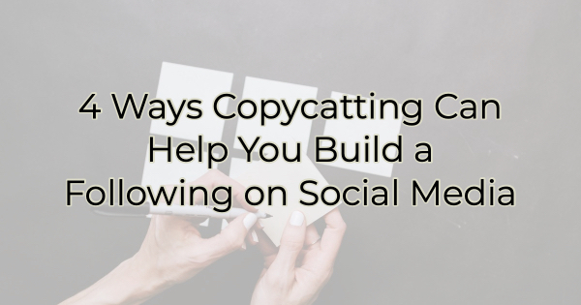

Building a following on your desired platform on social media requires a bit of luck but there are some things you can do to help that luck (and other users) find your profile. But sadly, those things probably don’t have a lot to do with your business.

4 Ways Copycatting Can Build a Following on Social Media

Most business owners I talk to have tons of ideas for showcasing their goods and services. For those with a sexy brand, viewers eat that up. But you need to get there (to sexy brand status) before talking about yourself will be effective in building an audience. For the time being, go for these ideas below that use things that have already been done. Let’s work on gathering a crowd, so you have someone to talk to and hear your offers.

Give Them Something to Connect With
Think of your target market. How old are they? What gender? What stage of life? Now think about what that person finds amusing. What do they reminisce about or love? What are their sacred cows or what events/pop culture made the biggest impressions? Imagine you’re trying to woo Gen Xers. Take a trip down memory lane (in a Little Red Corvette, perhaps) with videos and posts from the 80s. Ask them questions about what kind of lunch box they carried. What posters did they have on their wall? Did they wear jelly shoes or have a Cabbage Patch Doll? Share what you or your employees remember from the 80s. Post pictures of the 80s. The time of our youth leaves a huge imprint on our lives. Use that power to reach your ideal audience.

Think Bigger
Many people are feeling lost these days. Financial losses, bank collapses, shootings, lots of bad news and it’s hard to always look past it. Be an inspiration. People need that. Talk about something larger than your business. Share life tips. Matthew McConaughey is building an empire providing logical inspiration. You can too even if it’s only in the form of image quotes. People want to be around a proponent of positivity.

Have a Shtick
Being an unusual presence on social media will get you noticed. But one unusual act is not enough to keep people coming back. Take a note from comedians and get a shtick or a gimmick. If you have a successful one, you’ll become known for it. Get on TikTok or Reels and:

- talk about crazy things your spouse asks you to do
- ask deep questions with funny answers or funny questions with deep answers (a funeral director wrote a book about outlandish questions she gets about the dead)
- point out obvious dumb ideas
- dress up your 4-year-old as your high school English teacher and let her give grammar advice.

Most people don’t like change and they bond with the predictability of a shtick. They’ll come back over and over to see what you’re doing next.

Use Pop Culture and Current Affairs
When it comes to building a social media following, don't be afraid to hitch yourself to a wagon and ride that gravy train. There are trends on social media, that everyone jumps on and while you may be thinking--everyone's doing it--do it anyway. If you can't think of a trend to copy after scrolling through your streams, listen to what people are talking about in entertainment monologues on comedic news programs and late-night shows. Try the opening monologue on a show like Saturday Night Live, for instance. If people are talking about it, you want to be too. Don’t forget local issues or frustrations that may be causing people to roll their eyes. If you can make light of it, people will respond.

The only exception to this advice is the topics of religion and politics. You don't want to alienate a potential customer or follower by talking about these divisive topics—with one exception. If you are sure your ideal demographic would enjoy it, then go with it (but keep it positive). Some businesses are closely aligned with political or religious ideologies; and in those cases, addressing taboo topics may actually work for you.

It seems like an oxymoron to tell you that to stand out you should be like everyone else. However, the crowd responds to familiarity, and that creates connections. So, if you can play with something people recognize and yet do it in a way that's all your own, you'll make an impression and build an audience on social media.

Christina Metcalf is a writer/ghostwriter who believes in the power of story. She works with small businesses, chambers of commerce, and business professionals who want to make an impression and grow a loyal customer/member base. She loves road trips, hates exclamation points, and is waiting for the day when AI can make her dinner and clean the house at an attractive price point.
_______________________________________
Twitter: @christinagsmith
Facebook: @tellyourstorygetemtalking
LinkedIn: @christinagsmith

