4+ Tips for Attracting More Tourists to Your Business

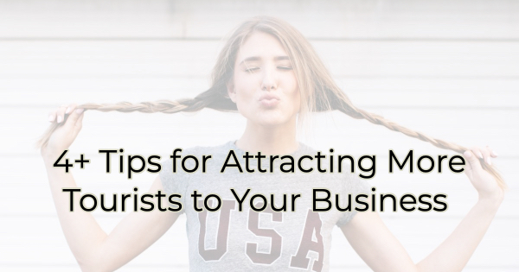

It’s that time of year again and many of us are preparing for a return to normal when it comes to the seasonal onslaught of tourism. Even with high transportation costs people are traveling and still—hopefully—buying. If you’d like to attract more tourists to your place of business, here’s how you can prepare.

How to Appeal to Tourists
Many tourists are looking for something unique in a business, something they don’t have in their hometowns. Here are a few ideas to make a big impact on them whether you are in retail, the restaurant and bar industry, attractions, or services.

Create an Experience
Again, tourists are looking for something different. If you want them to visit you need to offer them an experience. This could be a class, special tasting, photo op, or any other “special” time.

Whatever you decide on it needs to be marketed in a variety of outlets. Don’t forget your local chamber/visitors bureau. You might be surprised how many people stop in when they’re looking for recommendations.

Offer a Special
Create a deal or special with a short window of opportunity. Buy one, get one offers are a good idea or a free item/service with purchase. Your free service could even be a sampling of a much longer service to entice a future purchase. For instance, a mini head massage with every facial. You can even give them the ability to extend the service for additional money. Who can say no to a longer massage when they are already feeling the benefit?

Host Contests
Run fun contests just for travelers like a prize at the end of the day for people who have traveled the farthest or a small, free item for anyone who is visiting from over 1,500 miles away. (This is also a great way to build a mailing list if you ask them to give their address to be eligible. Just make sure you give them an opt-out option and be transparent that you are adding them.)

Be Travel-friendly
We all know the limitations of plane travel when it comes to carry-on liquids and such. And with the rates that airlines charge for checked bags, many people are hesitant to do that. If you want more tourists to buy from you, you should consider offering ways to get your goods home to them. Offering shipping options is also great for those who decide to send something to loved ones.

Speaking of…

Some tourists may love your business, but they simply aren’t ready to buy. Or they may love your business so much that they want to continue a relationship with you after they return home. Perhaps they’re even thinking about doing some holiday shopping with you but aren’t quite ready to do it on that visit. If you don’t offer a website or mailing list, you’re missing out. On my travels, I visited a handmade hat store. Her work was beautiful and reasonably priced. I wanted to buy my hat-collecting husband one for his birthday, but he was with me, and we were only in town for a few hours. I discretely asked her for a card and if she had a website. No, purchases could only be made in store. The customer/seller relationship evaporated at that time with no further chance for the sale.

If you want to draw more tourists in this summer, follow these tips. Just remember that the relationship doesn’t have to end when their trip does. If you’re smart about your offerings and have a mailing list, social media, and/or website to keep in touch, you can continue sales (and the relationship) well into the future.

Christina Metcalf is a writer/ghostwriter who believes in the power of story. She works with small businesses, chambers of commerce, and business professionals who want to make an impression and grow a loyal customer/member base. She loves road trips, hates exclamation points, and believes the world would be a better place if we all had our own theme song that played when we entered the room. What would yours be?
_______________________________________
Twitter: @christinagsmith
Facebook: @tellyourstorygetemtalking
LinkedIn: @christinagsmith

